|  |
| --- |
| **Terrorism Analysis**          Under the guidance of  Dr. Sylvester Fernandes,  Yogendra Singh          By  Ayushi Singhal |

# 1

**Table of Contents:**

1. **Introduction …………………………………………………………...……………..6**
2. **My work and implementation…………………………………………....………….7 2.1 About Data Set………………………………………………………....………...7** 
   1. **About User Interface UI………………………………………………...………8** 
      1. **Map tool……………………………………………………………...…...8**
      2. **Chart tool…………………………………………………………….......8 2.3 Explanation of Code………….. ………………………………………………...9 2.3.1 Libraries used…………………………………………………………....9**

**2.3.2 Main Function…………………………………………..…………….. 10 2.3.2.1 Load data………………………………………..…………….11 2.3.2.2 Open browser……………………………………..…………..14**

**2.3.2.3 Create app UI…………………………………….…………..14**

1. **Software requirements…………………………………………………..…………31 4. Result………………………………………………………………….....………….32 5. Conclusion and Future work…………………………………………….………...61**

**6. Acknowledgement………………………………………………………….……….62 7. References………………………………………………………………….………..63**

**8. Biography………………………………………………………………….………...64**

**List of Figures:**

**Fig. 3.1: Execution of Program on Visual Studio Code**

**Fig. 3.2: Global Map Tool - Application depicting without any input in dropdowns and range slider**

**Fig. 3.3: Global Map Tool - Application depicting loading of graph**

**Fig. 3.4: Global Map Tool - The whole data of terrorism in the world is shown without any filters**

**Fig. 3.5**:​ **Global Map Tool - On hover of cursor onto an event shows the details of the**​  **event**

**Fig. 3.6: Global Map Tool - Few months are selected as per the user requirements through dropdown**

**Fig. 3.7: Global Map Tool - The graph shows filtered data as per selected months**

**Fig. 3.8: Global Map Tool - Few dates are selected as per selected months**

**Fig. 3.9: Global Map Tool - The graph shown filtered as per selected months and date**

**Fig.3.10: Global Map Tool - Few regions are selected**

**Fig. 3.11: Global Map Tool - The graph shows filtered data as per selected month, date and region**

**Fig. 3.12: Global Map Tool - Few countries are selected based on the selected region Fig. 3.13: Global Map Tool - The graph shows filtered data as per selected month, date, region and country**

**Fig. 3.14: Global Map Tool - Few states are selected based on the selected regions and countries**

**Fig. 3.15: Global Map Tool - The graph shows filtered data as per selected month, date, region, country and state**

**Fig. 3.16: Global Map Tool - Few cities are selected based on selected regions, countries and states**

**Fig. 3.17: Global Map Tool - The graph shows filtered data as per selected month, date, region, country, state and city**

**Fig. 3.18: Global Map Tool - An attack type is selected**

**Fig. 3.19: Global Map Tool - The graph shows filtered data as per selected month, date, region, country, state, city and attack type**

**Fig. 3.20: Global Map Tool - range of years are selected**

**Fig. 3.21: Global Map Tool - The graph shows filtered data as per selected month, date, region, country, city, attack type and years**

**Fig. 3.22: India Map Tool - Application depicting without any inputs in dorpdown and range slider**

**Fig. 3.23: India Map Tool - The whole data of India is shown without any filters Fig. 3.24: India Map Tool - Few months are selected as per the user requirements through dropdown**

**Fig. 3.25: India Map Tool - The graph shown filtered data as per selected month**

**Fig. 3.26: India Map Tool - Few dates are selected as per selected months**

**Fig. 3.27: India Map Tool - The graph shown filtered data as per selected month and date**

**Fig. 3.28: India Map Tool - Few states from india are selected**

**Fig. 3.29: India Map Tool - The graph shows filtered data as per selected month, date and state in india**

**Fig. 3.30: India Map Tool - Few cities are selected based on selected states and in india Fig. 3.31: India Map Tool - The graph shows filtered data as per selected month, date, states and few cities in India**

**Fig. 3.32: India Map Tool - An attack type is selected**

**Fig. 3.33: India Map Tool - the graph shows filtered data as per selected month, date,state , city in india and attack type**

**Fig. 3.34: India Map Tool - A range of year is selected**

**Fig. 3.35: India Map Tool - The graph shows filtered data as per selected month, date, year, state and city in india and attack type**

**Fig. 3.36: Global chart Tool - Application depicting without any inputs (region selected as default) in dropdown and range slider**

**Fig. 3.37: Global chart Tool - the whole data without any filters**

**Fig. 3.38: Global chart Tool - Search filter is selected as per user requirements**

**Fig. 3.39: Global chart Tool - The chart shows filtered data as per search filter**

**Fig. 3.40: Global chart Tool - range of year slider is selected as per the user requirement Fig. 3.41: Global chart Tool - The graph shows filtered data as per search filter and year slider**

**Fig. 3.42: Global chart Tool - Application depicting dropdown (part 1)**

**Fig. 3.43: Global chart Tool - Application depicting dropdown (part 2)**

**Fig. 3.44: Global chart Tool Type of attack is selected as per user requirements**

**Fig. 3.45: Global chart Tool - the graph shows filtered data as per type of attack**

**Fig. 3.46: Global chart Tool - search filter is selected as per user requirements (exp) Fig. 3.47: Global chart Tool - the graph shows filtered data as per search filter and type of attack**

**Fig. 3.48: Global chart Tool - A range of year is selected using range slider**

**Fig. 3.49: Global chart Tool - The graph shows filtered data as per attack type, search filter and year slider**

**Fig. 3.50: India chart Tool - The whole data of terrorism in india is shown without any filters (regions is selected as default)**

**Fig. 3.51: India chart Tool - - The graph shows filtered data as per region in India**

**Fig. 3.52: India chart Tool - - Type of weapon is selected as per user requirements through dropdown**

**Fig. 3.53: India chart Tool - The graph shows filtered data as per type of weapon**

**Fig. 3.54: India chart Tool - The search filter is selected as per user requirement (exp) Fig. 3.55: India chart Tool - The graph shows filtered data as per search filter and type of weapon**

**Fig. 3.56: India chart Tool - Range of years is selected using range slider Fig. 3.57: India chart Tool - The graph shows filtered data as per type of weapon, search filter and year slider**

**1 Introduction:**

As we have more information at our fingertips than ever​ before, the importance of data visualization has been greater than it is right now. Data visualization is the graphical representation of information and data with the help of charts, graphs, maps for getting insights of data.

In this project, Terrorism analysis with insights using

python, Data set containing 1,91,465 records derived from Global Terrorism Database was used to analyze the information and project it in the form of maps and graphs. Initially the whole data set was visualized in the form of maps and charts. Depending on the user inputs, like date, month, year, region, country, state, city and attack type, only the preferential data had been filtered.

The User Interface (UI) contains multiple dropdowns, a range slider, map or graph tool and is user friendly.

# 2 My work and Implementation

## 2.1 ABOUT DATA SET:

The data set global_terror.csv contains the following columns:

* iyear → specifies the year of attack
* imonth → specifies the month of attack
* iday → specifies the day of attack
* country → specifies 205 unique countries
* country_txt → specifies the name of the country in accordance to country(unique code)
* Region → specifies 12 unique regions
* Region_txt → specifies the name of the region in accordance to region(unique code)
* Provstate → specifies 2580 unique province/ state
* City → specifies 39489 unique cities
* Latitude → specifies latitude of the location of attack
* Longitude → specifies longitude of the location of attack
* Attacktype1 → specifies 9 unique attack types
* Attacktype1_txt → specifies the name of attack type in accordance to attacktype1 (unique code)
* Targtype1 → specifies 22 unique target type
* Targtype1_txt → specifies the name of target type in accordance to targtype1 (unique code)
* Natlty1 → specifies unique nationalities
* Natlty1_txt → specifies the name of nationality in accordance to natlty1
* Gname → specifies the terrorist organization
* Weaptype1 → specifies the unique code of weapon
* Weaptype1_txt → specifies the name of the weapon in accordance to the weaptype1
* Nkill → specifies the number of people deceased in the attack - Propextent → specifies the unique code of the property loss.
* Propextent_txt → specifies the amount of the damage incurred during the attack

## 2.2 About User Interface (UI)

Visualization of data is doone and represented in the below two ways ● Map tool

* World map plot
* India map plot ● Chart tool
* World area chart - showing number of incident counts vs every year
* India specific area chart - showing number of incident counts vs every year

### 2.2.1 MAP TOOL

Map User Interface​

* There are seven dropdown and a year range slider in UI each for filtering the data as per user requirements based on the inputs - The dropdown UI are
* Months
* Date
* Region
* Country
* province/state
* City
* Attack type - The range slider is for
* Year
* The graph is also shown below them.(map). - There are few restriction like
* The user has to select month first and then day
* The user should select region before selecting country and similarity down the path
* Based on the data inputted, the data is filtered with the help of call backs
* The world map plot has a legend beside it, showing the attacktype based on the filters and they are clickable to select any
* India specific map plot: the region and country are fixed and set to south asia and india respectively. Rest everything works similarly to the world map tool.

### 2.2.2 Chart Tool:

The chart tool has a world chart tool and india specific chart tool Chart tool User Interface:

* Incidents grouped by region initially. But with the help of drop down, grouping can be changed to any of the following
* terrorist organization
* target nationality
* target type
* type of attack
* weapon type
* region
* country attacked.
* Search box filter
* Selecting range of years using range slider
* Area chart

The dropdown filter which groups incidents based on dropdown value, is also the legend of the area chart.

The search filters works as search for a specific requirement among all, like a country details or attack type or any.

**India specific area chart**:​ The region and country are fixed and set to South Asia and India respectively. Rest everything works similarly to the world chart tool.

## 2.3 Explanation of code

### 2.3.1 LIBRARIES USED:

|  |
| --- |
|  |
| import​ pandas ​as​ pd |
| import​ webbrowser |
|  |
| import​ dash |
| import​ dash_html_components ​as​ html |
| from​ dash.dependencies ​import​ Input, State, Output |
| import​ dash_core_components ​as​ dcc |
| import​ plotly.graph_objects ​as​ go |
| import​ plotly.express ​as​ px |
| from​ dash.exceptions ​import​ PreventUpdate |
|  |

Pandas:

* It is used to read and operate on data easily and flexibly like reading data from csv and to get particular columns as per requirement Webbrowser:
* It is used to open a tab in default browser you use Dash:
* It is used to create an app and a dummy server to host the website Dash_html_components:
* It consists of html components like headings, break, horizontal line etc.,

Dash.dependencies import input, state, output

* It is used in callbacks to take inputs and give outputs.

Dash_core_components:

* It has many useful components like graphs, maps, dropdowns, range slider etc., Plotly.graph_objects:
* It is used to generate figures Plotly.express:
* It is used make charts and graphs Dash.exception:
* It is used to prevent exceptions

Global variable declaration

|  |
| --- |
|  |
| app = dash.Dash() |
|  |

App = dash.Dash():

* It is the first step to make an app in dash. The object named app is created.

### 2.3.2 MAIN FUNCTION:

- The program execution is started here.

|  |
| --- |
|  |
| **if**​​**__name__**​ **==** ​**'__main__'**​**:** |
| **application()** |
|  |

Here application is a method or function which is invoked when the programs starts its execution.

|  |
| --- |
|  |
| def​ ​application​(): |
|  |
| load_data() |
|  |
| open_browser() |
|  |
| ​global​ app |
| app.layout = create_app_ui() |
|  |
| app.title = ​"Terrorism Analysis with Insights" |
|  |
| app.run_server() |
|  |
| ​print​(​"Stopped by the user"​) |
| ​#df = None |
| app = ​None |
|  |
|  |

Method named application contains the following components:

1. Load data
2. Open browser
3. create_ app_ui App.layout

* It stores the layout from create_app_ui App.title
* It specifies the title of the app

App.run_server

* It starts the server df=None and app=None:
* Once the program is terminated df and app are removed

#### 2.3.2.1 Load data​

|  |
| --- |
|  |
| def​ ​load_data​(): |
| dataset_name = ​"global_terror.csv" |
|  |
| pd.options.mode.chained_assignment = ​None |
|  |
| ​global​ df |
| df = pd.read_csv(dataset_name) |
|  |
| ​global​ month_list |
| month = { |
| ​"January"​:​1​, |
| ​"February"​: ​2​, |
| ​"March"​: ​3​, |
| ​"April"​:​4​, |
| ​"May"​:​5​, |
| ​"June"​:​6​, |
| ​"July"​: ​7​, |
| ​"August"​:​8​, |
| ​"September"​:​9​, |
| ​"October"​:​10​, |
| ​"November"​:​11​, |
| ​"December"​:​12 |
| } |
| month_list= [{​"label"​:key, ​"value"​:values} ​for​ key,values ​in​ month.items()] |
|  |
| ​global​ date_list |
| date_list = [x ​for​ x ​in​ ​range​(​1​, ​32​)] |
|  |
|  |
| ​global​ region_list |
| region_list = [{​"label"​: ​str​(i), ​"value"​: ​str​(i)} ​for​ i ​in​ ​sorted​( df[​'region_txt'​].unique().tolist() ) ] |
|  |
| ​global​ country_list |
| country_list = df.groupby(​"region_txt"​)[​"country_txt"​].unique().apply(​list​).to_dict() |
|  |
|  |
| ​global​ state_list |
| state_list = df.groupby(​"country_txt"​)[​"provstate"​].unique().apply(​list​).to_dict() |
|  |
|  |
| ​global​ city_list |
| city_list = df.groupby(​"provstate"​)[​"city"​].unique().apply(​list​).to_dict() |
|  |
|  |
| ​global​ attack_type_list |
| attack_type_list = [{​"label"​: ​str​(i), ​"value"​: ​str​(i)} ​for​ i ​in​ df[​'attacktype1_txt'​].unique().tolist()] |
|  |
|  |
| ​global​ year_list |
| year_list = ​sorted​ ( df[​'iyear'​].unique().tolist() ) |
|  |
| ​global​ year_dict |
| year_dict = {​str​(year): ​str​(year) ​for​ year ​in​ year_list} |
|  |
| ​global​ chart_dropdown_values |
| chart_dropdown_values = {​"Terrorist Organisation"​:​'gname'​, |
| ​"Target Nationality"​:​'natlty1_txt'​, |
| ​"Target Type"​:​'targtype1_txt'​, |
| ​"Type of Attack"​:​'attacktype1_txt'​, |
| ​"Weapon Type"​:​'weaptype1_txt'​, |
| ​"Region"​:​'region_txt'​, |
| ​"Country Attacked"​:​'country_txt' |
| } |
|  |
| chart_dropdown_values = [{​"label"​:keys, ​"value"​:value} ​for​ keys, value ​in |
| chart_dropdown_values.items()] |
|  |
|  |

**Load_data:**

* Dataset_ name = “global_terror.csv”
* The file name is stored in dataset_name.
* Df = pd.read_csv(dataset_name)
* It is used to read the data from csv file
* Each column values of the data set is read, unique names are selected and they are converted into a dictionary format

[{“label”: ”label name”, “value”: “value name”}, {“label”:

”label name1”, “value”: “value name1”}, …………………………..]

As this format is used in the dropdown, the column values are converted into this format.

All the columns values are collected and converted in the above format. The variables are made global, as they need to be available in the whole program. They are

* region_list
* Country_list
* state_list
* City_list
* Attack_type_list
* Year_dict
* chart_dropdown_values

* Whereas months_list and date_list are hard coded, as they are fixed - Few functions used are
* unique() → to get the unique values among all
* to_dict→ converts into dictionary
* to_list→ converts into list
* Basic for loops are used to iterate

#### 2.3.2.2 Open_browser

|  |
| --- |
|  |
| def​ ​open_browser​(): |
| webbrowser.open_new(​'​<http://127.0.0.1:8050/>​'​) |
|  |

* webbrowser.open_new(‘http://127.0.0.1:8050/​ ’)​
* It is used to open open the webpage (of the specified link) in default browser

#### 2.3.2.3 create_app_ui

|  |
| --- |
|  |
| def​ ​create_app_ui​(): |
|  |
| dropdown_style={ |
| ​'width'​: ​'99%'​, |
| ​'margin'​: ​'auto'​, |
| ​"padding-top"​: ​"4px"​, |
| ​"padding-bottom"​: ​"2px"​, |
| ​"border-radius"​:​"25px" |
| } |
|  |
| main_layout = html.Div( |
| ​style​={​"background-color"​: ​"#FFE9DB"​}, |
| ​className​=​"Test"​, |
| ​children​=[ |
| html.H1(​'Terrorism Analysis with Insights'​, ​id​=​'Main_title'​,​style​={​"text-align"​: |
| "center"​,​"background-color"​: ​"#FFA38A"​,​"margin"​:​"0"​,​"padding-top"​: ​"7px"​,​"padding-bottom"​: ​"7px"​}), |
| dcc.Tabs(​id​=​"Tabs"​, ​value​=​"Map"​,​children​=[ |
| dcc.Tab(​label​=​"Map tool "​ ​u​"​\U0001F30D​"​ ,​selected_style​={​"fontWeight"​: |
| "bold"​},​style​={​"fontWeight"​: ​"bold"​},​id​=​"Map tool"​,​value​=​"Map"​,​children​=[ |
| dcc.Tabs(​id​ = ​"subtabs"​, ​value​ = ​"WorldMap"​,​children​ = [ |
| dcc.Tab(​label​=​"World Map tool "​ ​u​"​\U0001F30D​"​,​selected_style​={​"fontWeight"​: |
| "bold"​},​style​={​"fontWeight"​: ​"bold"​}, ​id​=​"World"​, ​value​=​"WorldMap"​), |
| dcc.Tab(​label​=​"India Map tool "​ ​u​"​\U0001F30D​"​,​selected_style​={​"fontWeight"​: |
| "bold"​},​style​={​"fontWeight"​: ​"bold"​}, ​id​=​"India"​, ​value​=​"IndiaMap"​) |
| ]), |
| dcc.Dropdown( |
| ​id​=​'month'​, |
| ​options​=month_list, |
| ​placeholder​=​'Select Month'​, |
| ​multi​ = ​True​, |
| ​style​=dropdown_style |
| ), |
| dcc.Dropdown( |
| ​id​=​'date'​, |

|  |
| --- |
| ​placeholder​=​'Select Day'​, |
| ​multi​ = ​True​, |
| ​style​=dropdown_style |
| ), |
| dcc.Dropdown( |
| ​id​=​'region_dropdown'​, |
| ​options​=region_list, |
| ​placeholder​=​'Select Region'​, |
| ​multi​ = ​True​, |
| ​style​=dropdown_style |
| ), |
| dcc.Dropdown( |
| ​id​=​'country_dropdown'​, |
| ​options​=[{​'label'​: ​'All'​, ​'value'​: ​'All'​}], |
| ​placeholder​=​'Select Country'​, |
| ​multi​ = ​True​, |
| ​style​=dropdown_style |
| ), |
| dcc.Dropdown( |
| ​id​=​'state_dropdown'​, |
| ​options​=[{​'label'​: ​'All'​, ​'value'​: ​'All'​}], |
| ​placeholder​=​'Select State or Province'​, |
| ​multi​ = ​True​, |
| ​style​=dropdown_style |
| ), |
| dcc.Dropdown( |
| ​id​=​'city_dropdown'​, |
| ​options​=[{​'label'​: ​'All'​, ​'value'​: ​'All'​}], |
| ​placeholder​=​'Select City'​, |
| ​multi​ = ​True​, |
| ​style​=dropdown_style |
| ), |
| dcc.Dropdown( |
| ​id​=​'attacktype_dropdown'​, |
| ​options​=attack_type_list, |
| ​placeholder​=​'Select Attack Type'​, |
| ​multi​ = ​True​, |
| ​style​=dropdown_style |
| ), |
|  |

|  |
| --- |
| html.H4(​'Select the Year'​, ​id​=​'year_title'​,​style​={​"padding-left"​: ​"20px"​}), |
| dcc.RangeSlider( |
| ​id​=​'year_slider'​, |
| ​min​=​min​(year_list), |
| ​max​=​max​(year_list), |
| ​value​=[​min​(year_list),​max​(year_list)], |
| ​marks​=year_dict, |
| ​step​=​None |
| ), |
| ]), |
| dcc.Tab(​label​ = ​"Chart Tool "​ ​u​"​\U0001F4CA​"​,​selected_style​={​"fontWeight"​: |
| "bold"​},​style​={​"fontWeight"​: ​"bold"​}, ​id​=​"chart tool"​, ​value​=​"Chart"​, ​children​=[ |
| dcc.Tabs(​id​ = ​"subtabs2"​, ​value​ = ​"WorldChart"​,​children​ = [ |
| dcc.Tab(​label​=​"World Chart tool "​u​"​\U0001F4CA​"​,​selected_style​={​"fontWeight"​: |
| "bold"​},​style​={​"fontWeight"​: ​"bold"​}, ​id​=​"WorldC"​, ​value​=​"WorldChart"​), |
| dcc.Tab(​label​=​"India Chart tool "​u​"​\U0001F4CA​"​,​selected_style​={​"fontWeight"​: |
| "bold"​},​style​={​"fontWeight"​: ​"bold"​}, ​id​=​"IndiaC"​, ​value​=​"IndiaChart"​)]), |
| dcc.Dropdown(​id​=​"Chart_Dropdown"​, ​options​ = chart_dropdown_values, ​placeholder​=​"Select |
| option"​, ​value​ = ​"region_txt"​,​style​={​'width'​: ​'99%'​,​'margin'​: ​'auto'​,​"padding-top"​: ​"2px"​,​"padding-bottom"​: |
| "2px"​,​"border-radius"​:​"25px"​}), |
| html.Br(), |
| html.Hr(), |
| html.Center( dcc.Input(​id​=​"search"​, ​placeholder​=​"Search |
| Filter"​,​style​={​"width"​:​"97%"​,​"padding-bottom"​: ​"10px"​,​"padding-top"​: ​"10px"​,​"border-radius"​:​"25px"​}) |
| ), |
| html.Hr(), |
| html.Br(), |
| html.H4(​'Select the Year'​, ​id​=​'year_titlee'​,​style​={​"padding-left"​: ​"20px"​}), |
| dcc.RangeSlider( |
| ​id​=​'cyear_slider'​, |
| ​min​=​min​(year_list), |
| ​max​=​max​(year_list), |
| ​value​=[​min​(year_list),​max​(year_list)], |
| ​marks​=year_dict, |
| ​step​=​None |
| ), |
| html.Br() |
| ]), |
| ]), |
| dcc.Loading(​children​=[dcc.Graph(​id​=​'graph-object'​)],​type​=​'graph'​,​style​={​"backgroundColor"​: |
| "transparent"​,​"z-index"​:​"1"​,​"position"​:​"absolute"​}), |
| html.Footer(​id​= ​"footer"​, |
| ​style​={​"padding-bottom"​: ​"1px"​}, |
| ​children​=[ |
| html.H3(​style​={​"text-align"​: ​"center"​},​children​=[ |
| html.H3(​children​=​"Made with "​,​style​={​"display"​: ​"inline"​}), |
| html.H3(​children​=​"​\u2764​"​,​style​={​"color"​:​"red"​,​"display"​: ​"inline"​}), |
| html.H3(​children​=​" by ESWAR"​,​style​={​"display"​: ​"inline"​}), |
| ]) |
| ]) |
|  |
|  |
| ]) |
|  |
| ​return​ main_layout |
|  |

* dropdown_style={

“Width” : “99%”,

“Margin” : “auto”,

“Padding-top” : “4px”,

“Padding-bottom” : “2px”,

“Border-radius” : ”25px” }

* Dropdown_style contains the styling for the dropdowns. (css styling) - Main_layout =
* It contains the whole layout of the webapp - It contains the following components
* html.H1 to html.H6 → specifies the headings with their sizes in decreasing order respectively.
* Title
* Id → specifies a unique identification for the component
* Style = {....} → specifies styling for the particular components
* dcc.Tab and tabs → used to create tab and subtabs
* label→ specifying the name of the tab
* selected _style = {....} → specifies the selected styling
* style={...} → specifies style of tab
* Id → specifies unique identification for the component
* Value
* Children = [....] → specifies the subcomponents inside that tab
* dcc.Dropdown
* Id → specifies unique identification for the component
* Options
* Placeholder → specifies the name of the dropdown when nothing is selected
* Multi = true → specifies that multiple values can be selected in the dropdown
* style={...} → specifies style of dropdown
* dcc.Rangeslider → to select range ( between any two values)
* Id → specifies unique identification for the component
* Min
* Max
* Value
* Marks → specifies the numbers on the ring slider - html.Br → specifies a break.
* html.Hr → specifies horizontal line Return main_layout:
* Returns the main layout which has been created in the above steps.

|  |
| --- |
|  |
| @app.callback​(dash.dependencies.Output(​'graph-object'​, ​'figure'​), |
| [ |
| dash.dependencies.Input(​"Tabs"​, ​"value"​), |
| dash.dependencies.Input(​'month'​, ​'value'​), |
| dash.dependencies.Input(​'date'​, ​'value'​), |
| dash.dependencies.Input(​'region_dropdown'​, ​'value'​), |
| dash.dependencies.Input(​'country_dropdown'​, ​'value'​), |
| dash.dependencies.Input(​'state_dropdown'​, ​'value'​), |
| dash.dependencies.Input(​'city_dropdown'​, ​'value'​), |
| dash.dependencies.Input(​'attacktype_dropdown'​, ​'value'​), |
| dash.dependencies.Input(​'year_slider'​, ​'value'​), |
| dash.dependencies.Input(​'cyear_slider'​, ​'value'​), |
|  |
| dash.dependencies.Input(​"Chart_Dropdown"​, ​"value"​), |
| dash.dependencies.Input(​"search"​, ​"value"​), |
| dash.dependencies.Input(​"subtabs2"​, ​"value"​) |
| ] |
| ) |

|  |
| --- |
|  |
| def​ ​update_app9_ui​(​Tabs​, ​month_value​, |
| date_value​,​region_value​,​country_value​,​state_value​,​city_value​,​attack_value​,​year_value​,​chart_year_selector |
| , ​chart_dp_value​, ​search​, |
| ​subtabs2​): |
| figure = ​None |
|  |
| ​if​ Tabs == ​"Map"​: |
| ​print​(​"Data Type of month value = "​ , ​str​(​type​(month_value))) |
| ​print​(​"Data of month value = "​ , month_value) |
|  |
| ​print​(​"Data Type of Day value = "​ , ​str​(​type​(date_value))) |
| ​print​(​"Data of Day value = "​ , date_value) |
|  |
| ​print​(​"Data Type of region value = "​ , ​str​(​type​(region_value))) |
| ​print​(​"Data of region value = "​ , region_value) |
|  |
| ​print​(​"Data Type of country value = "​ , ​str​(​type​(country_value))) |
| ​print​(​"Data of country value = "​ , country_value) |
|  |
| ​print​(​"Data Type of state value = "​ , ​str​(​type​(state_value))) |
| ​print​(​"Data of state value = "​ , state_value) |
|  |
| ​print​(​"Data Type of city value = "​ , ​str​(​type​(city_value))) |
| ​print​(​"Data of city value = "​ , city_value) |
|  |
| ​print​(​"Data Type of Attack value = "​ , ​str​(​type​(attack_value))) |
| ​print​(​"Data of Attack value = "​ , attack_value) |
|  |
| ​print​(​"Data Type of year value = "​ , ​str​(​type​(year_value))) |
| ​print​(​"Data of year value = "​ , year_value) |
|  |
| ​# year_filter |
| year_range = ​range​(year_value[​0​], year_value[​1​]+​1​) |
| new_df = df[df[​"iyear"​].isin(year_range)] |
|  |
| ​# month_filter |
| ​if​ month_value==[] ​or​ month_value ​is​ ​None​: |
| ​pass |
| ​else​: |

|  |
| --- |
| ​if​ date_value==[] ​or​ date_value ​is​ ​None​: |
| new_df = new_df[new_df[​"imonth"​].isin(month_value)] |
| ​else​: |
| new_df = new_df[new_df[​"imonth"​].isin(month_value) |
| & (new_df[​"iday"​].isin(date_value))] |
|  |
| ​# region, country, state, city filter |
| ​if​ region_value==[] ​or​ region_value ​is​ ​None​: |
| ​pass |
| ​else​: |
| ​if​ country_value==[] ​or​ country_value ​is​ ​None​ : |
| new_df = new_df[new_df[​"region_txt"​].isin(region_value)] |
| ​else​: |
| ​if​ state_value == [] ​or​ state_value ​is​ ​None​: |
| new_df = new_df[(new_df[​"region_txt"​].isin(region_value))& |
| (new_df[​"country_txt"​].isin(country_value))] |
| ​else​: |
| ​if​ city_value == [] ​or​ city_value ​is​ ​None​: |
| new_df = new_df[(new_df[​"region_txt"​].isin(region_value))& |
| (new_df[​"country_txt"​].isin(country_value)) & |
| (new_df[​"provstate"​].isin(state_value))] |
| ​else​: |
| new_df = new_df[(new_df[​"region_txt"​].isin(region_value))& |
| (new_df[​"country_txt"​].isin(country_value)) & |
| (new_df[​"provstate"​].isin(state_value))& |
| (new_df[​"city"​].isin(city_value))] |
|  |
| ​if​ attack_value == [] ​or​ attack_value ​is​ ​None​: |
| ​pass |
| ​else​: |
| new_df = new_df[new_df[​"attacktype1_txt"​].isin(attack_value)] |
|  |
| mapFigure = go.Figure() |
| ​if​ new_df.shape[​0​]: |
| ​pass |
| ​else​: |
| new_df = pd.DataFrame(​columns​ = [​'iyear'​, ​'imonth'​, ​'iday'​, ​'country_txt'​, ​'region_txt'​, ​'provstate'​, |
| ​'city'​, ​'latitude'​, ​'longitude'​, ​'attacktype1_txt'​, ​'nkill'​]) |
|  |
| new_df.loc[​0​] = [​0​, ​0​ ,​0​, ​None​, ​None​, ​None​, ​None​, ​None​, ​None​, ​None​, ​None​] |

|  |
| --- |
|  |
|  |
| mapFigure = px.scatter_mapbox(new_df, |
| ​lat​=​"latitude"​, |
| ​lon​=​"longitude"​, |
| ​color​=​"attacktype1_txt"​, |
| ​hover_name​=​"city"​, |
| ​hover_data​=[​"region_txt"​, ​"country_txt"​, ​"provstate"​,​"city"​, |
| "attacktype1_txt"​,​"nkill"​,​"iyear"​,​"imonth"​, ​"iday"​], |
| ​zoom​=​1 |
| ) |
| mapFigure.update_layout(​mapbox_style​=​"open-street-map"​, |
| ​autosize​=​True​, |
| ​margin​=​dict​(​l​=​20​, ​r​=​20​, ​t​=​20​, ​b​=​20​), |
| ) |
|  |
| figure = mapFigure |
|  |
| ​elif​ Tabs==​"Chart"​: |
| figure = ​None |
|  |
|  |
| year_range_c = ​range​(chart_year_selector[​0​], chart_year_selector[​1​]+​1​) |
| chart_df = df[df[​"iyear"​].isin(year_range_c)] |
|  |
|  |
| ​if​ subtabs2 == ​"WorldChart"​: |
| ​pass |
| ​elif​ subtabs2 == ​"IndiaChart"​: |
| chart_df = chart_df[(chart_df[​"region_txt"​]==​"South Asia"​) &(chart_df[​"country_txt"​]==​"India"​)] |
| ​if​ chart_dp_value ​is​ ​not​ ​None​ ​and​ chart_df.shape[​0​]: |
| ​if​ search ​is​ ​not​ ​None​: |
| chart_df = chart_df.groupby(​"iyear"​)[chart_dp_value].value_counts().reset_index(​name​ = |
| "count"​) |
| chart_df = chart_df[chart_df[chart_dp_value].str.contains(search, ​case​=​False​)] |
| ​else​: |
| chart_df = |
| chart_df.groupby(​"iyear"​)[chart_dp_value].value_counts().reset_index(​name​=​"count"​) |
|  |
|  |
| ​if​ chart_df.shape[​0​]: |
| ​pass |
| ​else​: |
| chart_df = pd.DataFrame(​columns​ = [​'iyear'​, ​'count'​, chart_dp_value]) |
|  |
| chart_df.loc[​0​] = [​0​, ​0​,​"No data"​] |
| chartFigure = px.area(chart_df, ​x​=​"iyear"​, ​y​ =​"count"​, ​color​ = chart_dp_value) |
| figure = chartFigure |
| ​return​ figure |
|  |

@app.callback(dash.dependencies.output(“graph-object”, “figure”),

[

dash.dependencies.Input(“tabs”,”value”),

…

…

…

…

…

dash.dependencies.Input(“subtabs2”,”value”)

]

)

* It collects all the inputs and gives a single output
* Then the method or function below is called automatically with parameters which are input in the above call back.

Figure = None

* Initially figure is initialized to none, everytime when the method is called.

If tabs == “map”:

* Condition checks whether the selected tab is mapped, if yes, executes the statement inside it.

Few print statements are used to check the type of the variables and the value inside them.

**#year_filter**

Year_range = range(year_value[0],year_value[1]+1) New_df = df[df[“iyear”].isin(year_range)]

* Year_range → stores the range of values in between the user input years from the range slider.
* Eg: 2000 - 2005 - selected by the user
* Year_value[0] = 2000, year_value[1] = 2005
* Range (x,y) → gives the values in between x and y including x but not y.
* So in order to get values from 2000 to 2005, range(year_value[0],year_value[1]+1) is used, as it specifies range of 2000 to 2006.
* Hence year_range contains values from 2000 to 2006
* Now dataset (df) is filtered based on the user input i.e year_range - If input is not given, whole data years are selected.

**# month_filter**

if month_value==[] or month_value is None:​ pass else: if date_value==[] or date_value is None:

new_df = new_df[new_df["imonth"].isin(month_value)] else:

new_df = new_df[new_df["imonth"].isin(month_value) & (new_df["iday"].isin(date_value))]

* If month is not selected, no filtering is done based on month or date
* else
* If date is not selected, the data is filtered based on month - Else, data is filtered based on both months and dates.

**# region, country, state, city filter**

if region_value==[] or region_value is None:​ pass else:

if country_value==[] or country_value is None :​ new_df = new_df[new_df["region_txt"].isin(region_value)]​ else:

if state_value == [] or state_value is None:

new_df = new_df[(new_df["region_txt"].isin(region_value))& (new_df["country_txt"].isin(country_value))] else:

if city_value == [] or city_value is None:

new_df = new_df[(new_df["region_txt"].isin(region_value))&

(new_df["country_txt"].isin(country_value)) & (new_df["provstate"].isin(state_value))] else:

new_df = new_df[(new_df["region_txt"].isin(region_value))&

(new_df["country_txt"].isin(country_value)) &

(new_df["provstate"].isin(state_value))& (new_df["city"].isin(city_value))]

* If region is not selected, no data is filtered
* Else,
* If country is not selected, data is filtered based on region
* Else,
* If state is not selected, data is filtered based on region and country
* Else
* If city is not selected, data is filtered based on region, country and state
* else , if city is selected, data is selected based on region, country, state and city

**#attacktype** if attack_value == [] or attack_value is None: pass else:

new_df = new_df[new_df["attacktype1_txt"].isin(attack_value)] - If attack type is not selected, the data is not filtered.

* Else, data is filtered based on attack type selected.

Now the final data for plotting on the map is ready in new_df with all the filters applied by the users.

**#figure**  mapFigure = go.Figure()​

* An empty figure is created and stored in mapFigure. if new_df.shape[0]: pass else:

new_df = pd.DataFrame(columns = ['iyear', 'imonth', 'iday', 'country_txt', 'region_txt', 'provstate',

'city', 'latitude', 'longitude', 'attacktype1_txt', 'nkill'])

new_df.loc[0] = [0, 0 ,0, None, None, None, None, None, None, None, None]

* If the shape of the new_df is greater than 0, there are atleast one record in new_df which are filtered based on user input
* Else, as there is no records in new_df, all column stored value are made to default i.e 0 or None

mapFigure = px.scatter_mapbox(new_df,​ lat="latitude", lon="longitude", color="attacktype1_txt", hover_name="city", hover_data=["region_txt", "country_txt", "provstate","city",

"attacktype1_txt","nkill","iyear","imonth", "iday"], zoom=1

)

* Scatter_mapbox → is used to scatter the points on the graph.
* new_df→ the data set is passed
* Lat → specifies latitude
* lon→ specifies longitude
* Color → specifies unique color based on attack type
* Hover_name → displays heading name
* Hover_data
* Zoom → range of zoom value between 1 t o15

mapFigure.update_layout(mapbox_style="open-street-map",​ autosize=True, margin=dict(l=20, r=20, t=20, b=20),

)

figure = mapFigure

* Update_layout → is used to update mapFigure
* Mapbox_style → specifies the style of map
* Autosize
* Margin → in all directions (left, right, top and bottom)

Finally mapFigure is stored in figure

elif Tabs=="Chart":

* Elif → else if, selected tab is chart, execute the following statements

year_range_c = range(chart_year_selector[0], chart_year_selector[1]+1)​ chart_df = df[df["iyear"].isin(year_range_c)]

* Data is filtered based on the years selected by the user - If no input is given, whole data years are selected.

if subtabs2 == "WorldChart":​

pass elif subtabs2 == "IndiaChart": chart_df = chart_df[(chart_df["region_txt"]=="South Asia")

&(chart_df["country_txt"]=="India")]

If subtabs2 is world chart, then no data is filtered

* Else, if subtabs2 is india chart, data is filtered as region is south asia and country is india.

if chart_dp_value is not None and chart_df.shape[0]: if search is not None:

chart_df =

chart_df.groupby("iyear")[chart_dp_value].value_counts().reset_index(name = "count") chart_df = chart_df[chart_df[chart_dp_value].str.contains(search, case=False)] else:

chart_df =

chart_df.groupby("iyear")[chart_dp_value].value_counts().reset_index(name="count")

* If input is given in chart dropdown,
* If input is also given for search, then data is filtered based on both chart dropdown and search
* Else, the data is filtered based on only chart dropdown.

if chart_df.shape[0]:

pass else:

chart_df = pd.DataFrame(columns = ['iyear', 'count', chart_dp_value])

* If the shape of the chart_df is greater than 0, there are atleast one record in chart_df which are filtered based on user input
* Else, as there are no records in chart_df, all column stored values are made to default.

chart_df.loc[0] = [0, 0,"No data"]​ chartFigure = px.area(chart_df, x="iyear", y ="count", color = chart_dp_value) figure = chartFigure return figure

* Based on chart_df data, area chart is made using area method.
* Chart_df as dataset
* X → x axis value
* Y → y axis value
* Color → chart_dp_value (unique colors) Finally chartFigure is stored in figure.

Return figure

Finally figure is returned as the output from the call back

|  |
| --- |
|  |
| @app.callback​( |
| Output(​"date"​, ​"options"​), |
| [Input(​"month"​, ​"value"​)]) |
| def​ ​update_date​(​month​): |
| option = [] |
| ​if​ month: |
| option= [{​"label"​:m, ​"value"​:m} ​for​ m ​in​ date_list] |
| ​return​ option |
|  |
|  |

* The above callback is used to add days to the dropdown based on the month selected.
* To be simple, the date_list values ranging from 1 to 31 are given as multiple months can be selected.
* Finally the date_dropdown options are returned.

|  |
| --- |
|  |
|  |
| @app.callback​([Output(​"region_dropdown"​, ​"value"​), |
| Output(​"region_dropdown"​, ​"disabled"​), |
| Output(​"country_dropdown"​, ​"value"​), |
| Output(​"country_dropdown"​, ​"disabled"​)], |
| [Input(​"subtabs"​, ​"value"​)]) |
| def​ ​update_r​(​tab​): |
| region = ​None |
| disabled_r = ​False |
| country = ​None |
| disabled_c = ​False |
| ​if​ tab == ​"WorldMap"​: |
| ​pass |
| ​elif​ tab==​"IndiaMap"​: |
| region = [​"South Asia"​] |
| disabled_r = ​True |
| country = [​"India"​] |
| disabled_c = ​True |
| ​return​ region, disabled_r, country, disabled_c |
|  |
|  |

* The above callback is used to disable region and country dropdown based on the user’s tab selection.
  + - If selected tab is world map, region and country are not disable
    - Else, if selected tab is india map, region and country are enabled and set to south asia and india respectively
    - It returns region, disabled_r, country, disabled_c

|  |
| --- |
|  |
| @app.callback​( |
| Output(​'country_dropdown'​, ​'options'​), |
| [Input(​'region_dropdown'​, ​'value'​)]) |
| def​ ​set_country_options​(​region_value​): |
| option = [] |
| ​if​ region_value ​is​ ​None​: |
| ​raise​ PreventUpdate |
| ​else​: |
| ​for​ var ​in​ region_value: |
| ​if​ var ​in​ country_list.keys(): |
| option.extend(country_list[var]) |
| ​return​ [{​'label'​:m , ​'value'​:m} ​for​ m ​in​ option] |
|  |
|  |

* The above callback is used to filter countries based on the selected regions.
  + If a region is not selected, then countries are not filtered.
  + Else, countries are filtered based on the regions and converted into the dictionary format which will be returned at the end.

|  |
| --- |
|  |
| @app.callback​( |
| Output(​'state_dropdown'​, ​'options'​), |
| [Input(​'country_dropdown'​, ​'value'​)]) |
| def​ ​set_state_options​(​country_value​): |
| option = [] |
| ​if​ country_value ​is​ ​None​ : |
| ​raise​ PreventUpdate |
| ​else​: |
| ​for​ var ​in​ country_value: |
| ​if​ var ​in​ state_list.keys(): |
| option.extend(state_list[var]) |
| ​return​ [{​'label'​:m , ​'value'​:m} ​for​ m ​in​ option] |
|  |
|  |

* The above callback is used to filter states based on the selected country.
  + If a country is not selected, then states are not filtered.
  + Else, states are filtered based on the country and converted into the dictionary format which will be returned at the end.

|  |
| --- |
|  |
| @app.callback​( |
| Output(​'city_dropdown'​, ​'options'​), |
| [Input(​'state_dropdown'​, ​'value'​)]) |
| def​ ​set_city_options​(​state_value​): |
| option = [] |
| ​if​ state_value ​is​ ​None​: |
| ​raise​ PreventUpdate |
| ​else​: |
| ​for​ var ​in​ state_value: |
| ​if​ var ​in​ city_list.keys(): |
| option.extend(city_list[var]) |
| ​return​ [{​'label'​:m , ​'value'​:m} ​for​ m ​in​ option] |
|  |
|  |

* The above callback is used to filter cities based on the selected states.
  + If a state is not selected, then cities are not filtered.
  + Else, cities are filtered based on the state and converted into the dictionary format which will be returned at the end.

The project or application can be executed directly from the Command prompt (cmd) or from any integrated development environment (ide) like spyder, visual studio code, pycharm etc.,

# 3.System Requirements

**System requirements:**

* Processor Type: Intel i3, i5 or higher
* RAM: 4 GB or above
* Disc Space: 250 GB
* Language: Python 3.5 x or above

**Software requirements:**

* Operating system: Microsoft Windows 7, Windows 8, Windows 10
* Language: Python 3.8x
* Python Modules: Pandas, webbroser
* Python Framework: Plotly’s Dash 1.0
* Python IDE or Command Prompt
* Internet Browser like Google Chrome, Mozilla Firefox, Microsoft Edge, Safari

**4. Results**

The application is executed on visual studio has shown below.

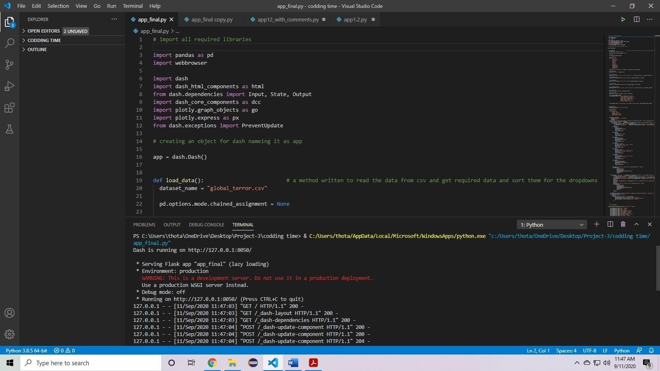

**Fig 3.1 : execution of program on Visual Studio Code**

Outputs:

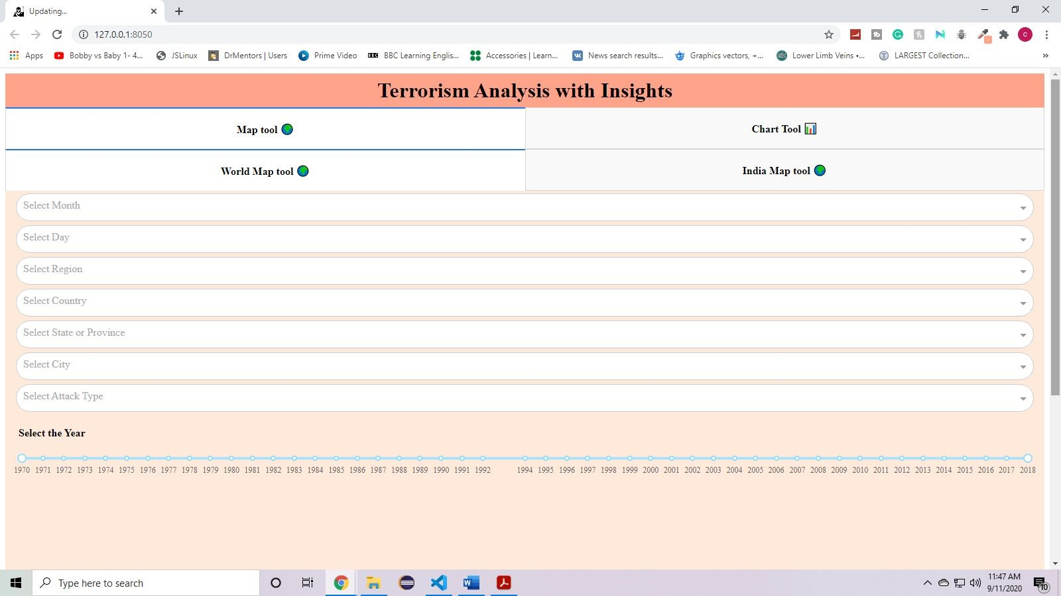

**Fig 3.2: Global Map Tool - application depicting without any inputs in dropdowns and range slider**

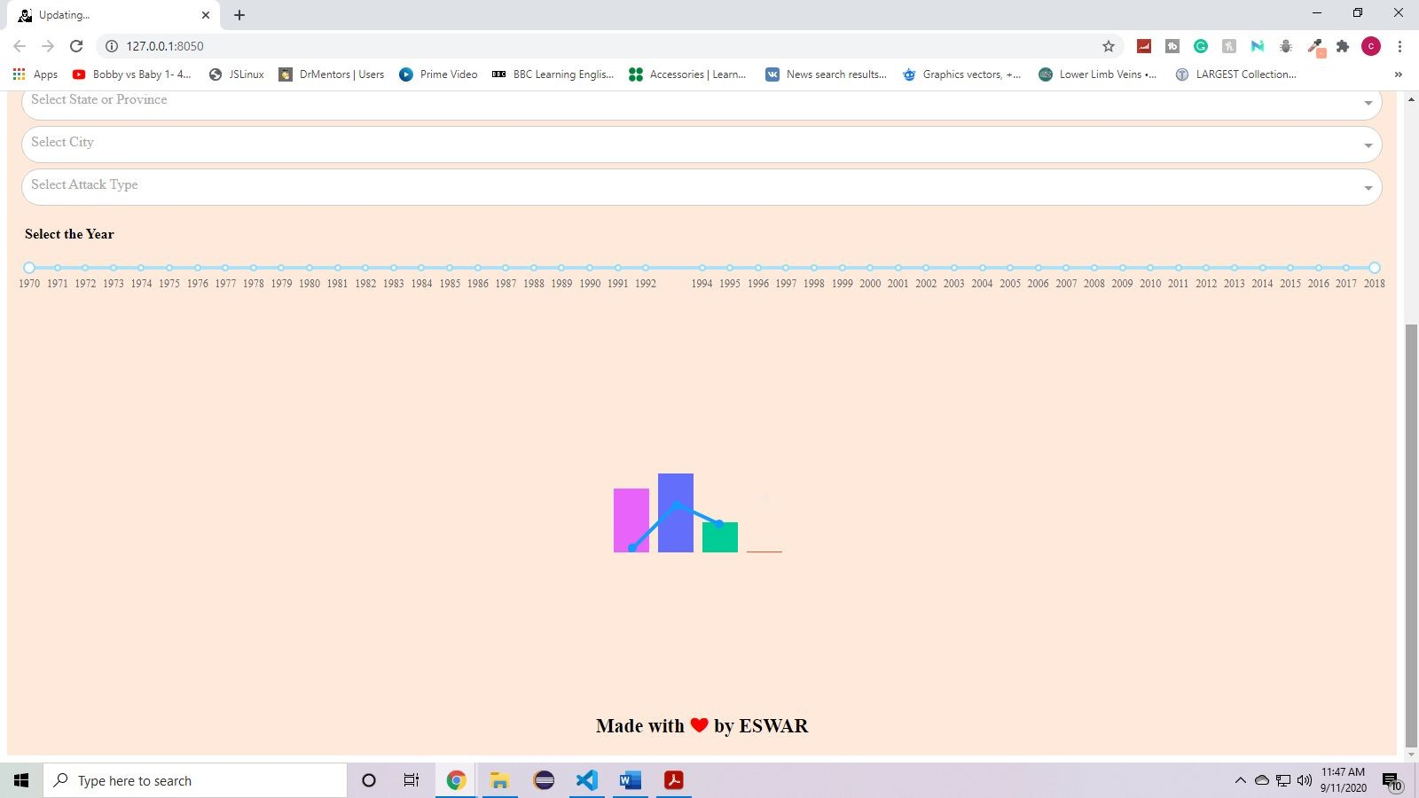

**Fig 3.3 : Global Map Tool - application depicting loading of graph**

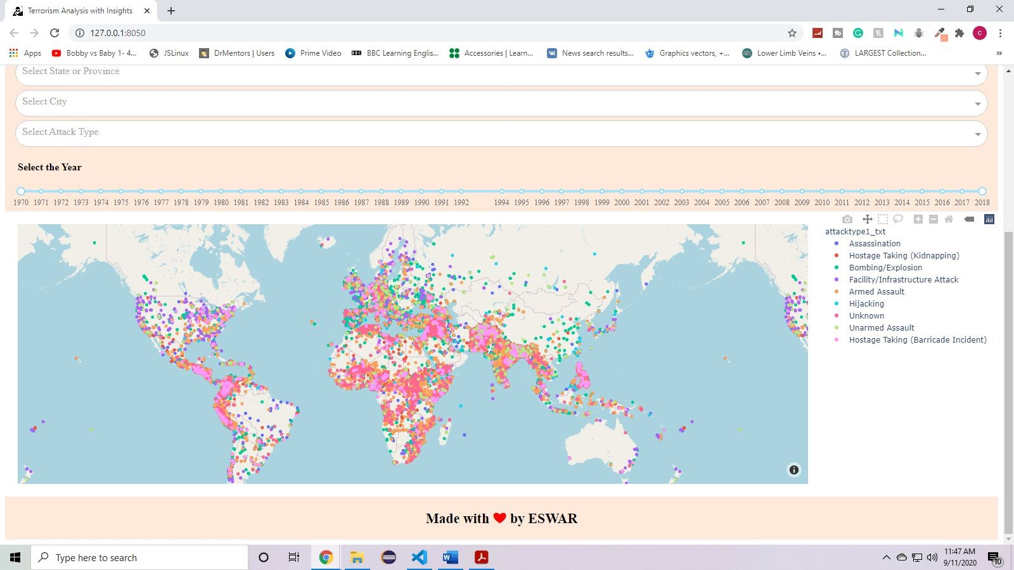

**Fig 3.4 : Global Map Tool - The whole data of terrorism in world is shown without any filters**

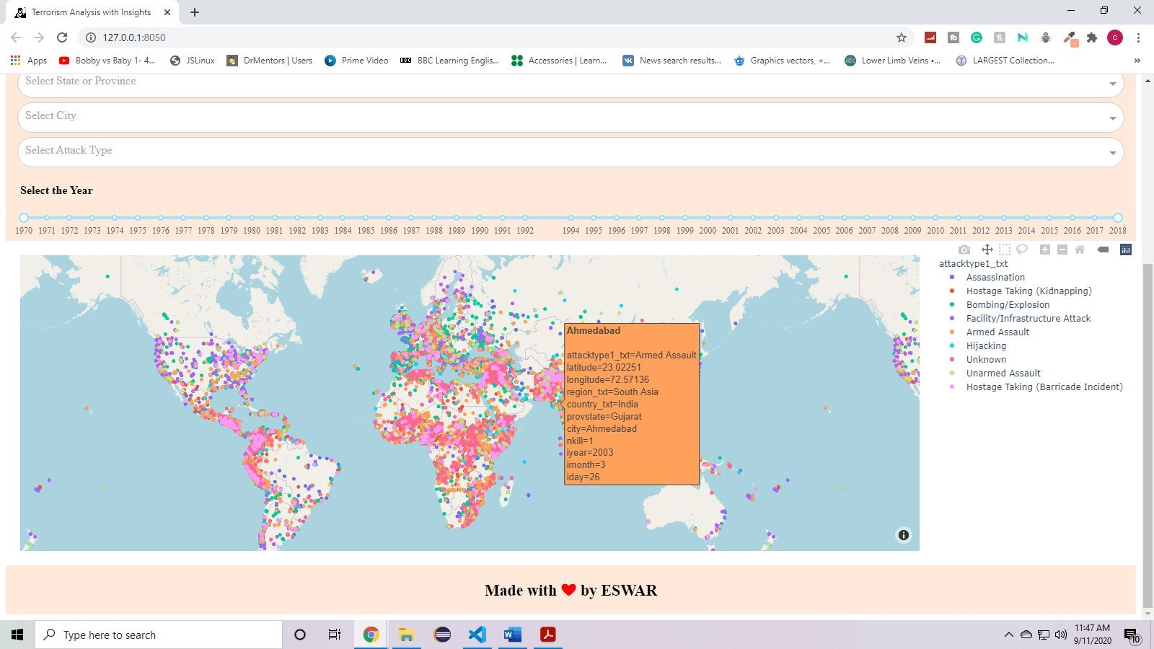

**Fig 3.5 : Global Map Tool - On hover of cursor onto an event shows the details of the event**

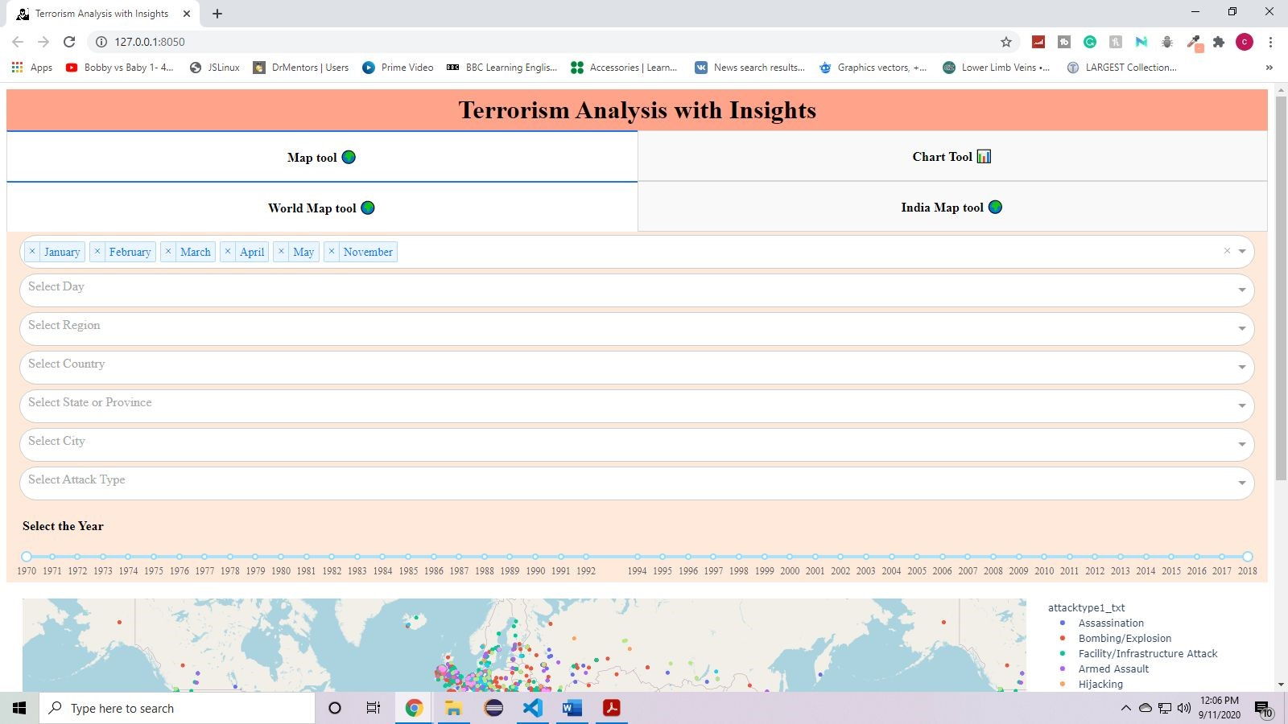

**Fig 3.6 : Global Map Tool - Few months are selected as per the user requirements through dropdown**

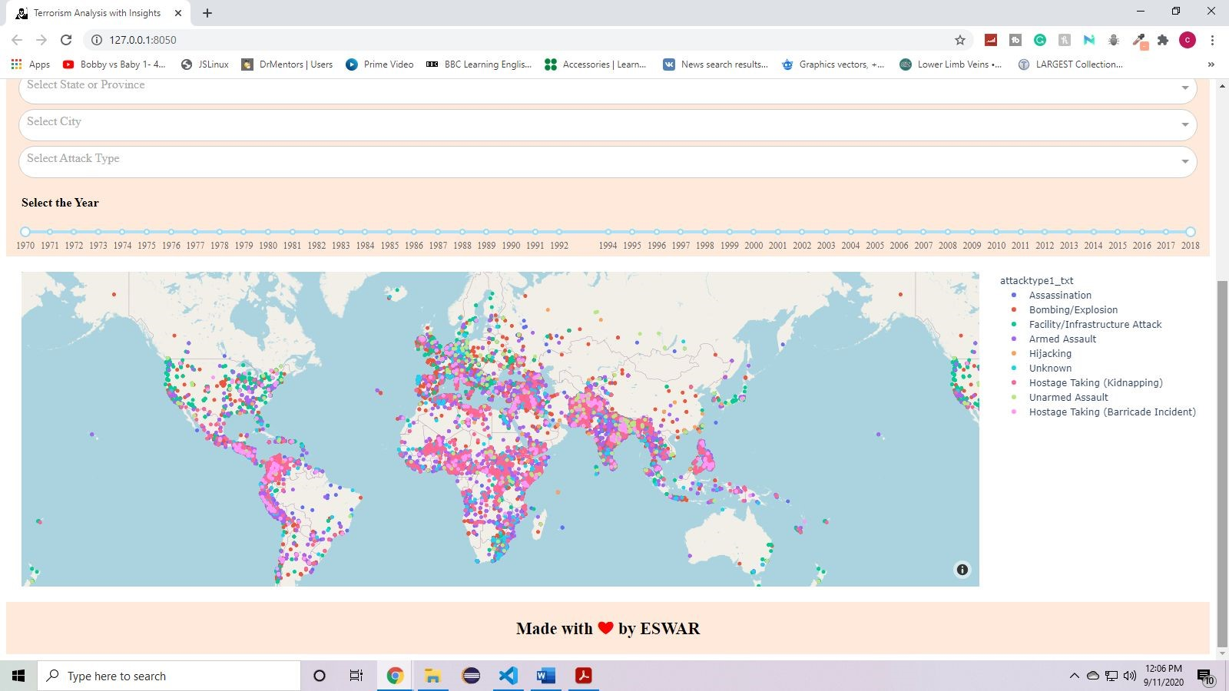

**Fig 3.7 : Global Map Tool - The graph shows filtered data as per selected months**

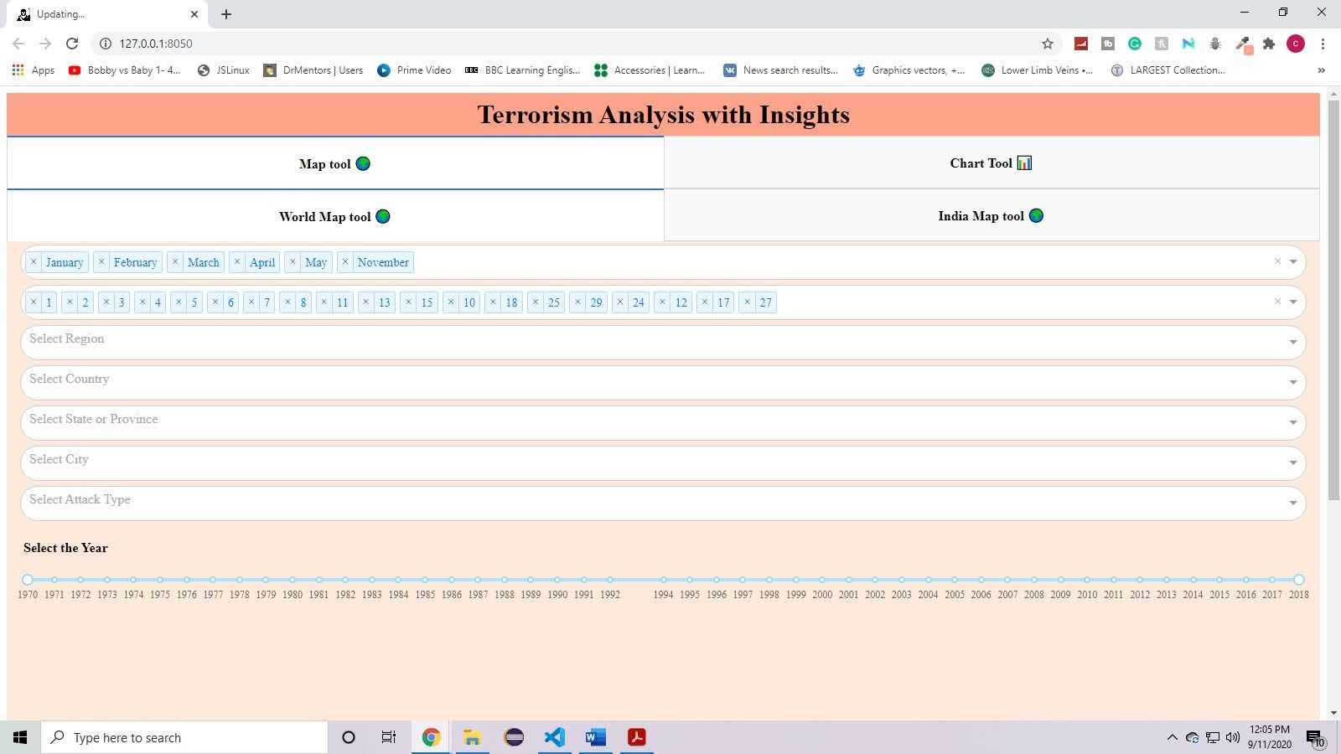

**Fig 3.8 : Global Map Tool - Few dates are selected as per selected months.**

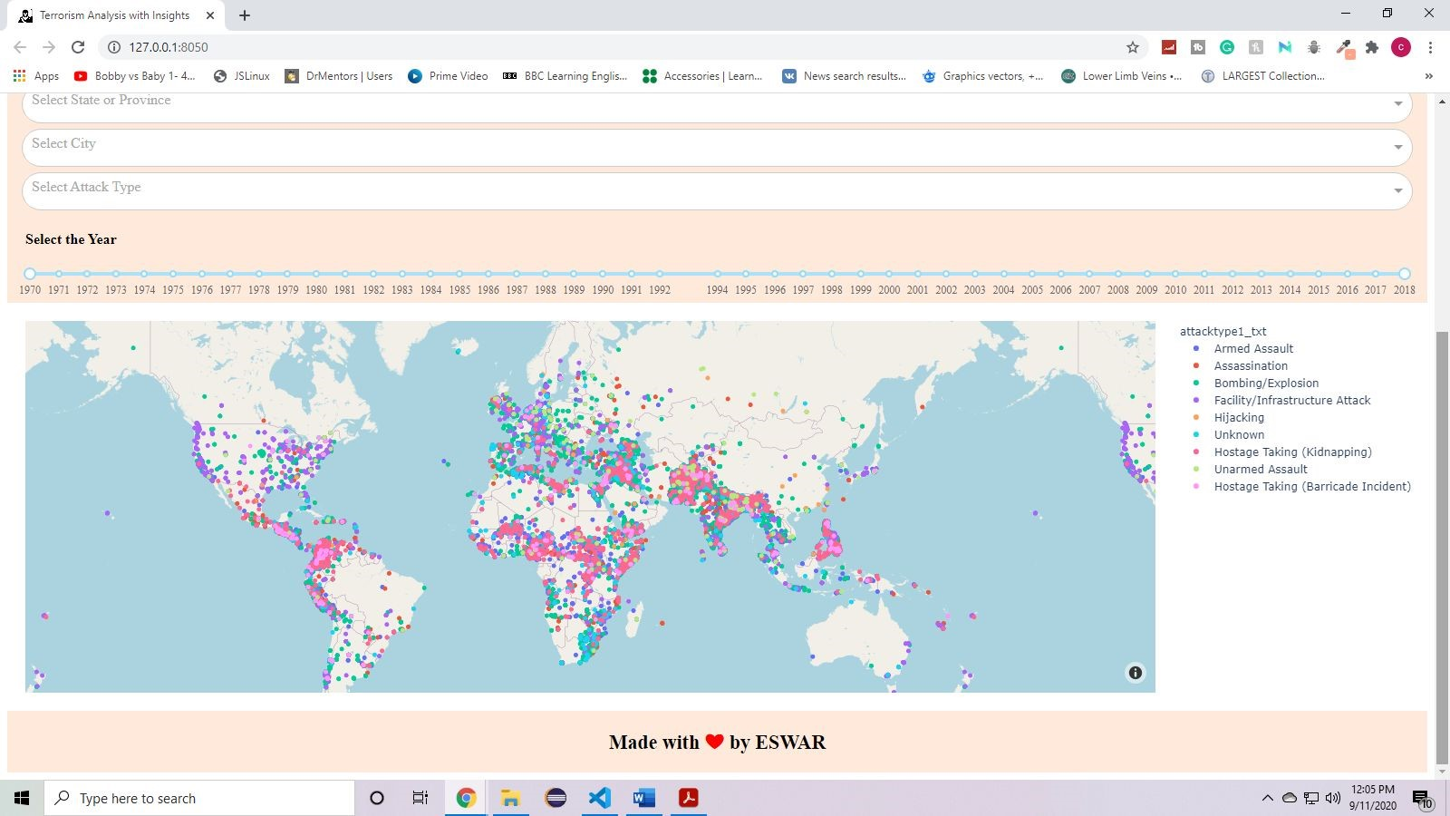

**Fig 3.9 : Global Map Tool - The graph shown filtered data as per selected months and date.**

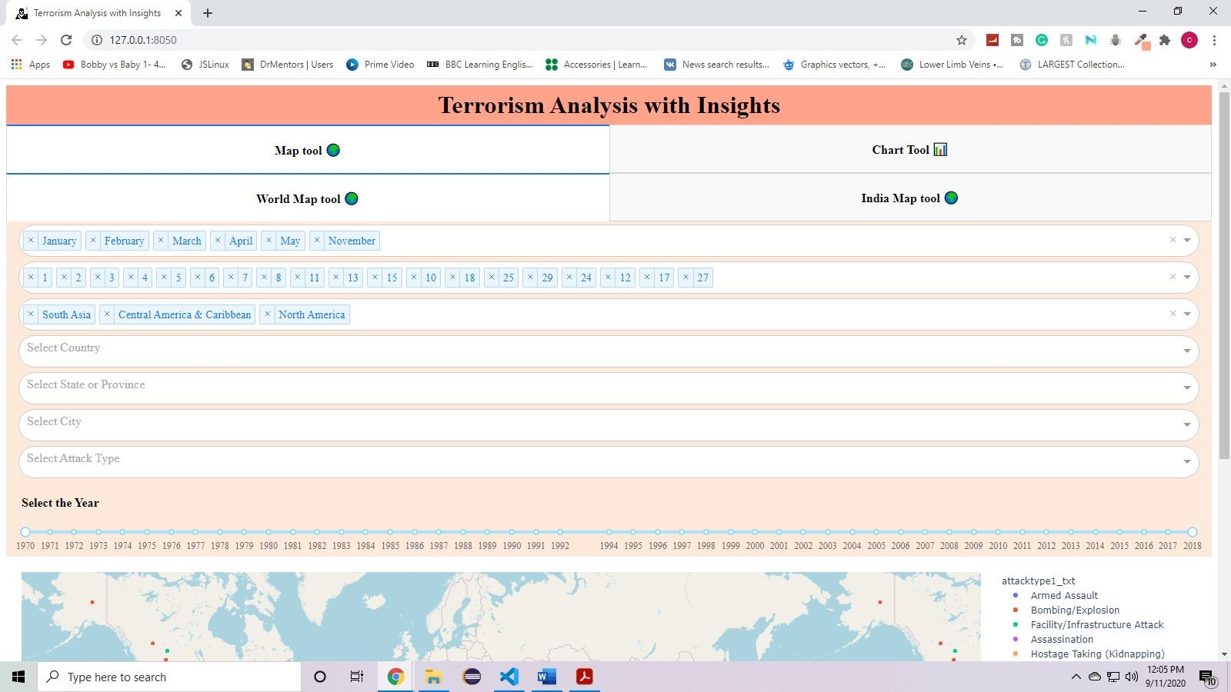

**Fig 3.10 : Global Map Tool - Few regions are selected**

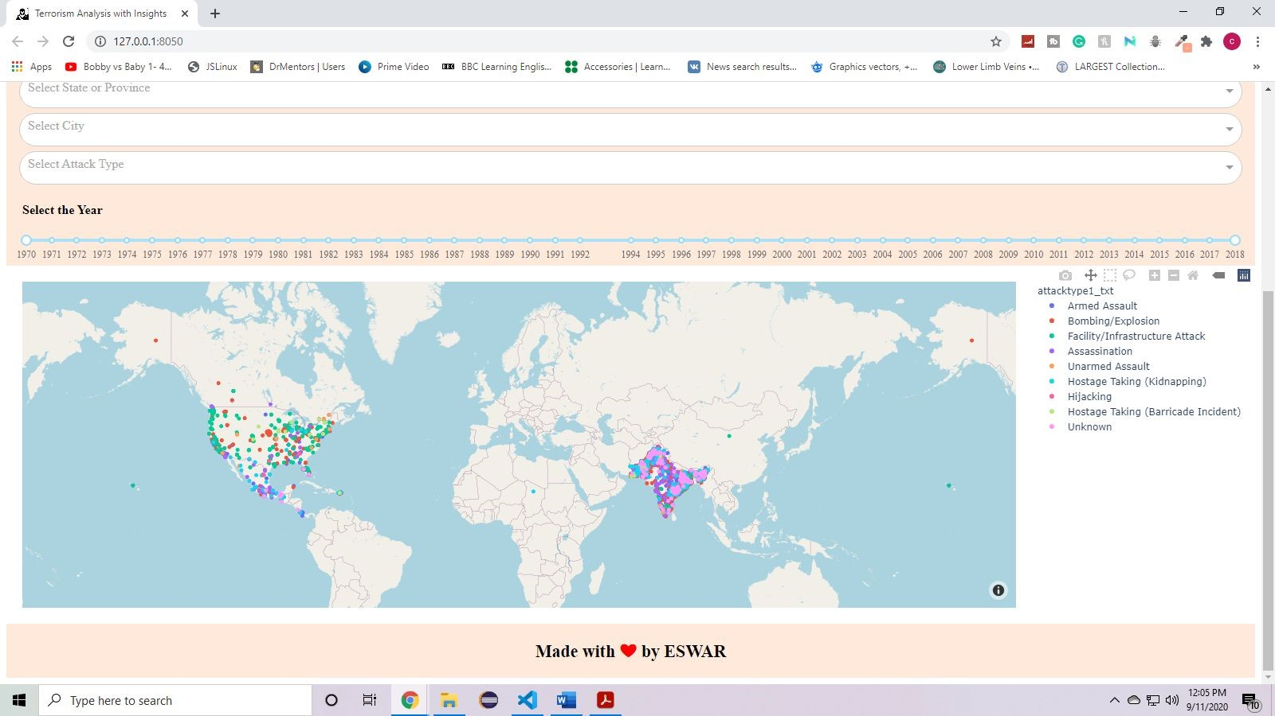

**Fig 3.11 : Global Map Tool - The graph shows filtered data as per selected month, date and region.**

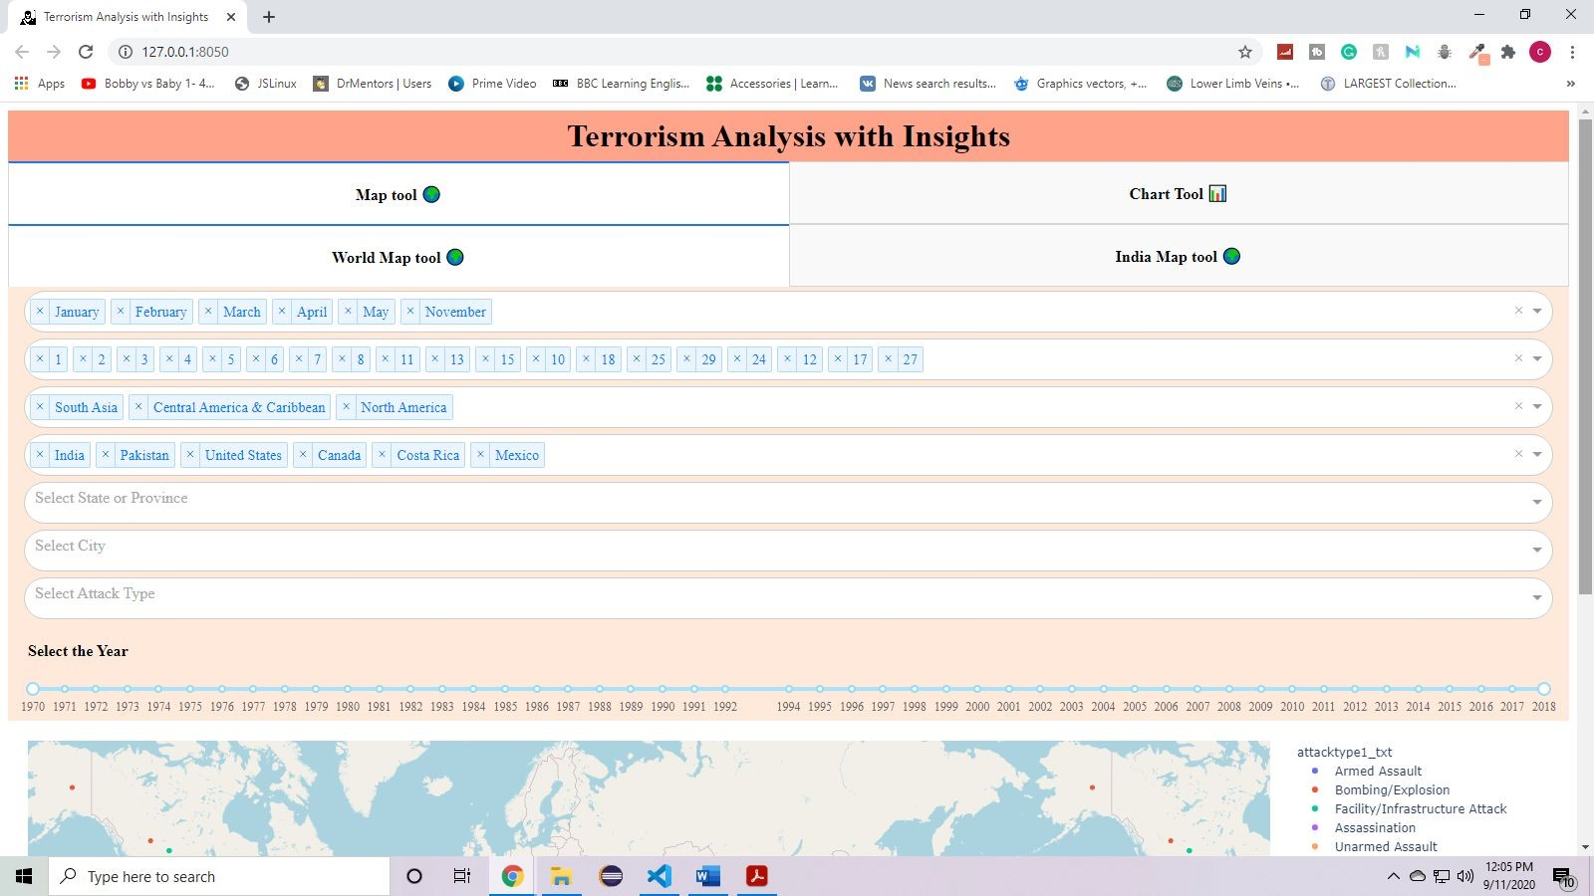

**Fig 3.12 : Global Map Tool - Few countries are selected based on the selected regions**



**Fig 3.13 : Global Map Tool - the graph shows filtered data as per selected month, date, region and country**

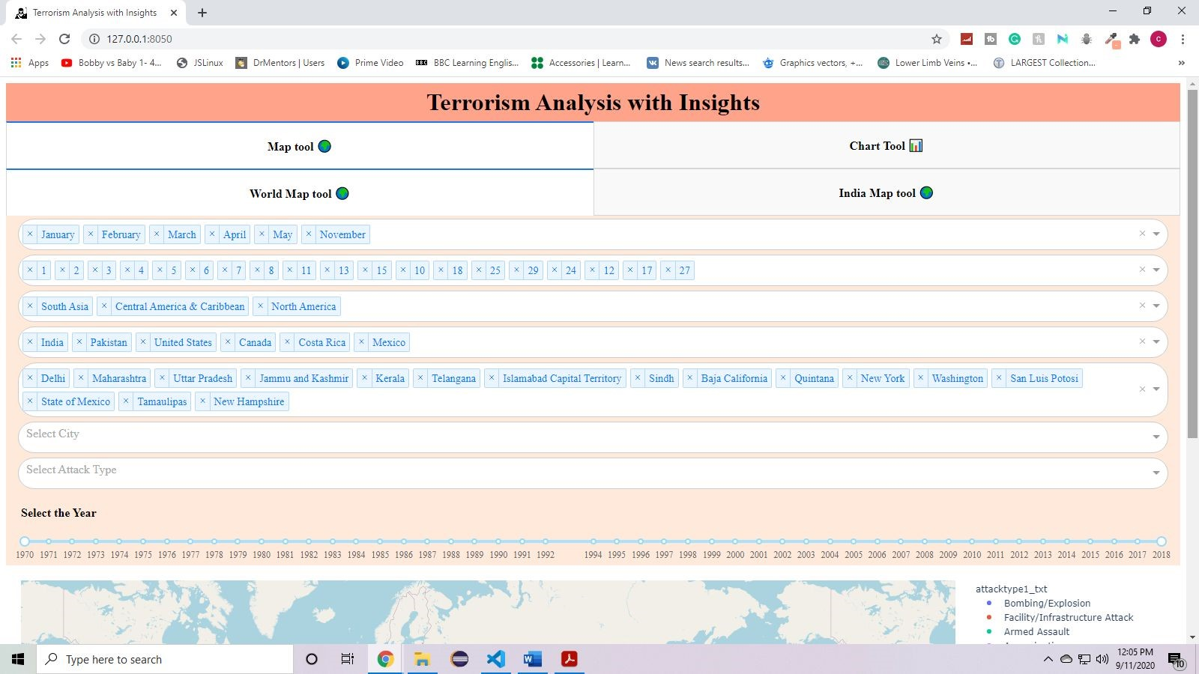

**Fig 3.14 : Global Map Tool - Few states are selected based on the selected regions and countries**

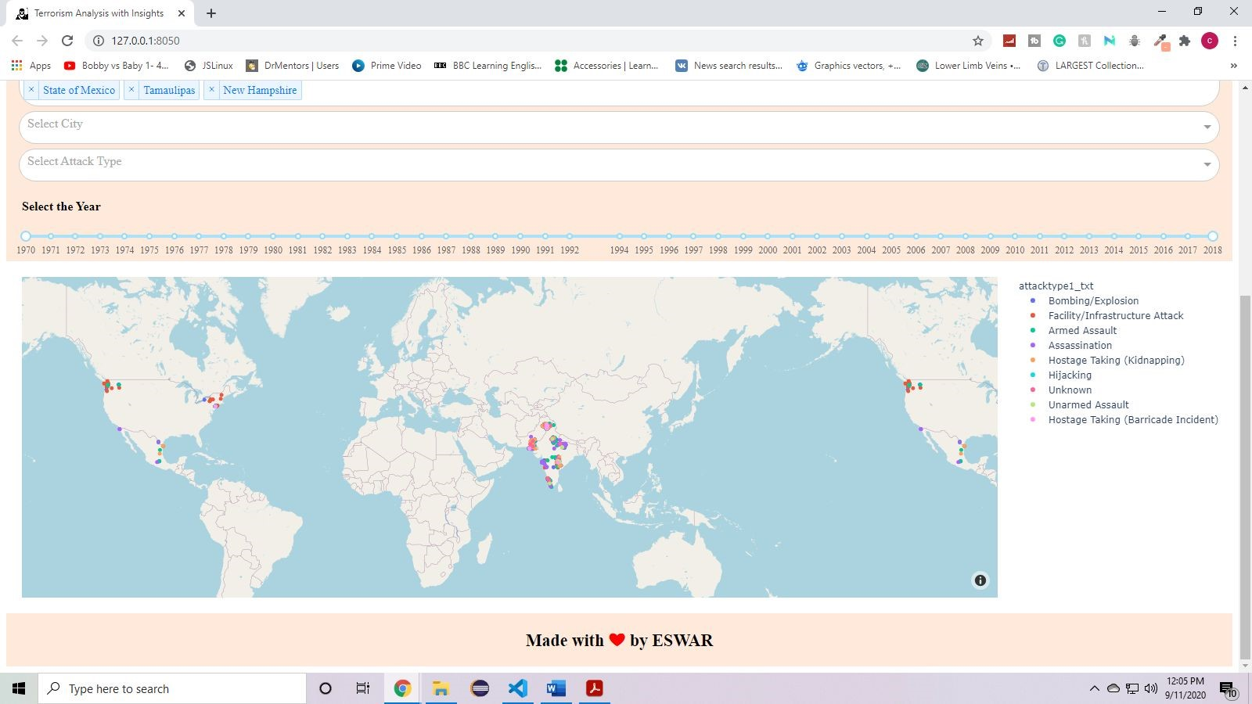

**Fig 3.15 : Global Map Tool - The graph shows filtered data as per selected month, date, region, country and state.**

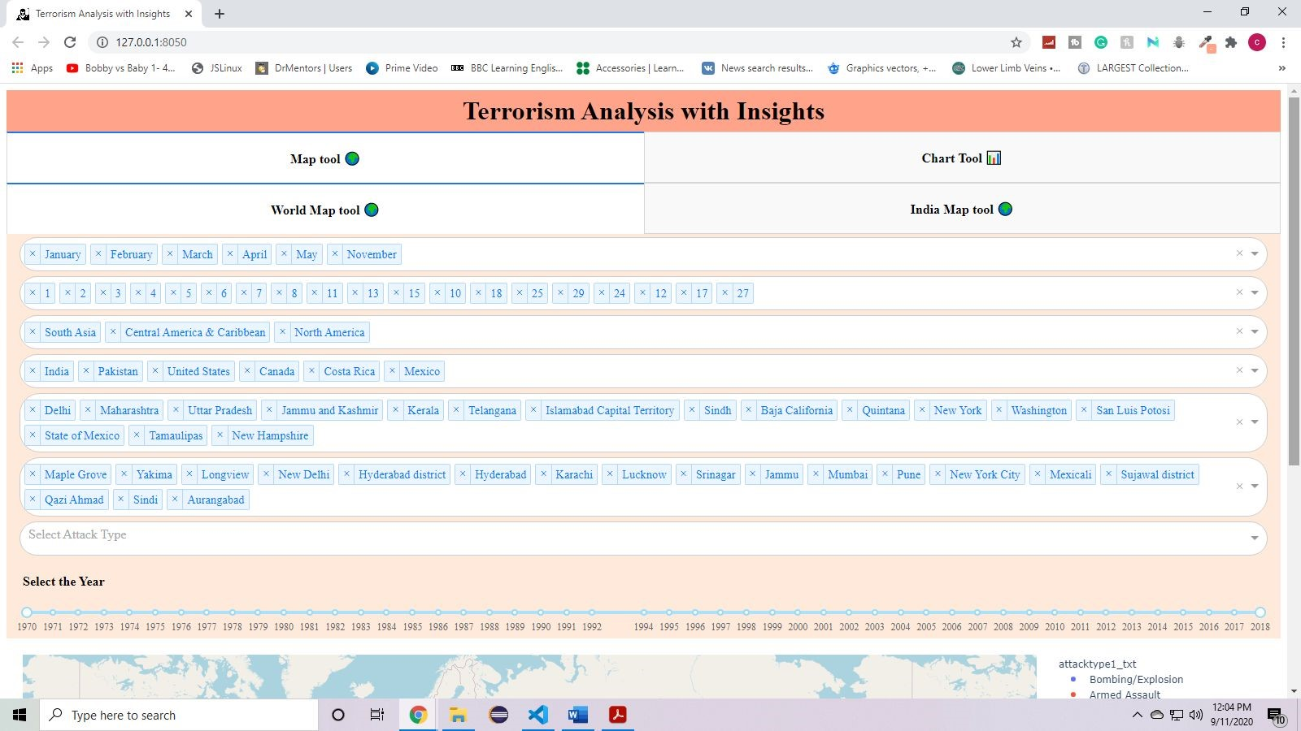

**Fig 3.16 : Global Map Tool - Few cities are selected based on selected regions, countries and states**

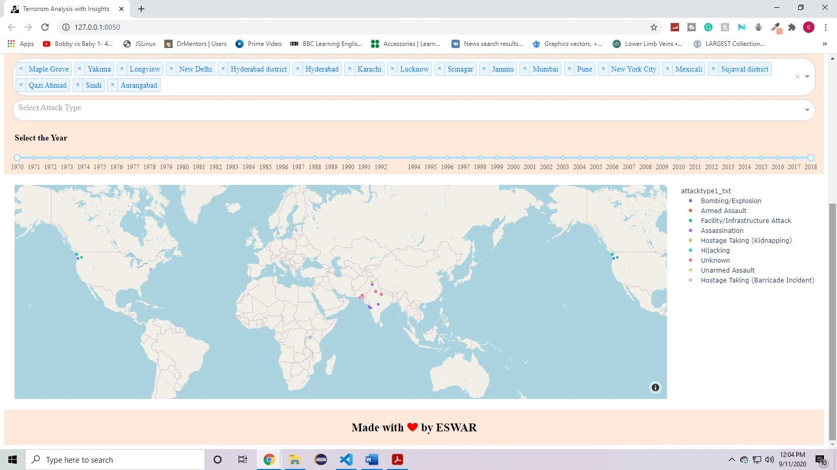

**Fig 3.17 : Global Map Tool - The graph shows filtered data as per selected month, date, region, country, state and city**

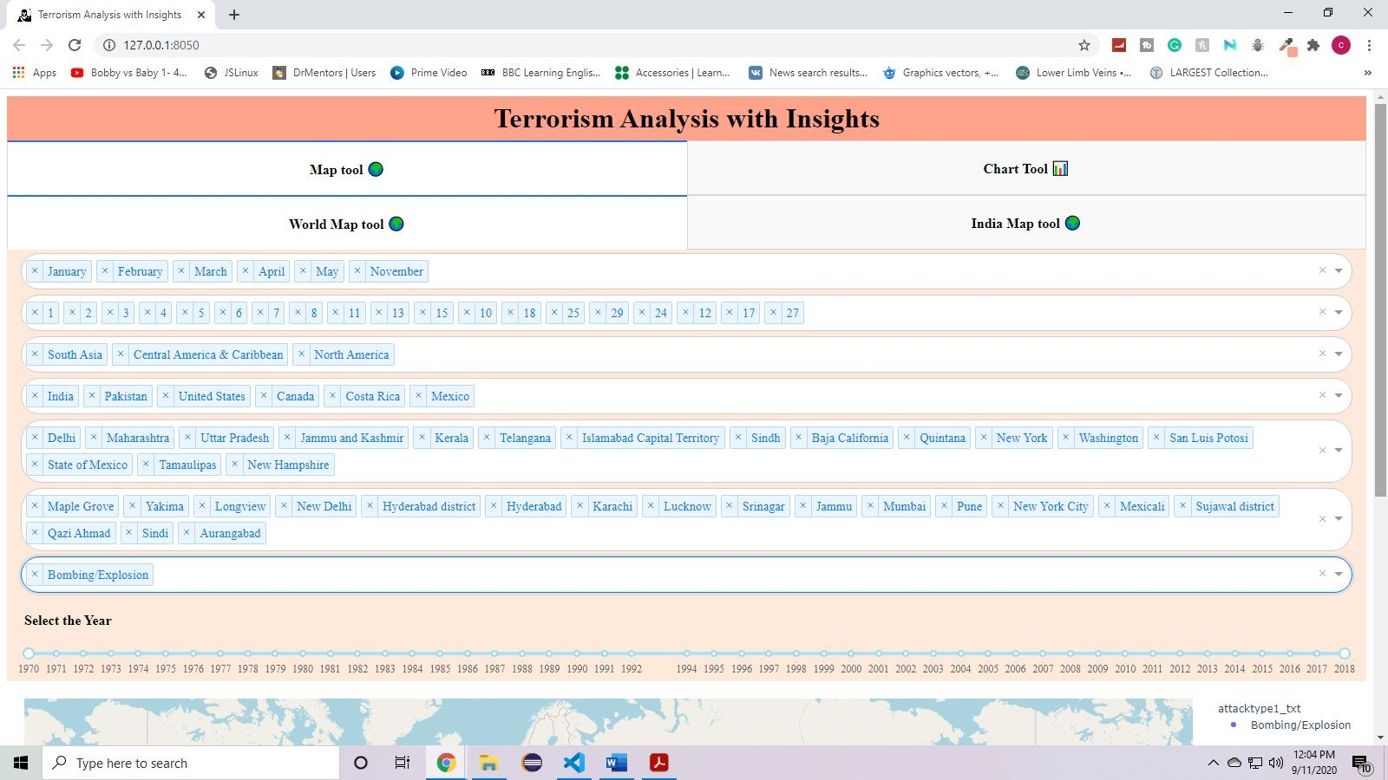

**Fig 3.18 : Global Map Tool - An attack type is selected**

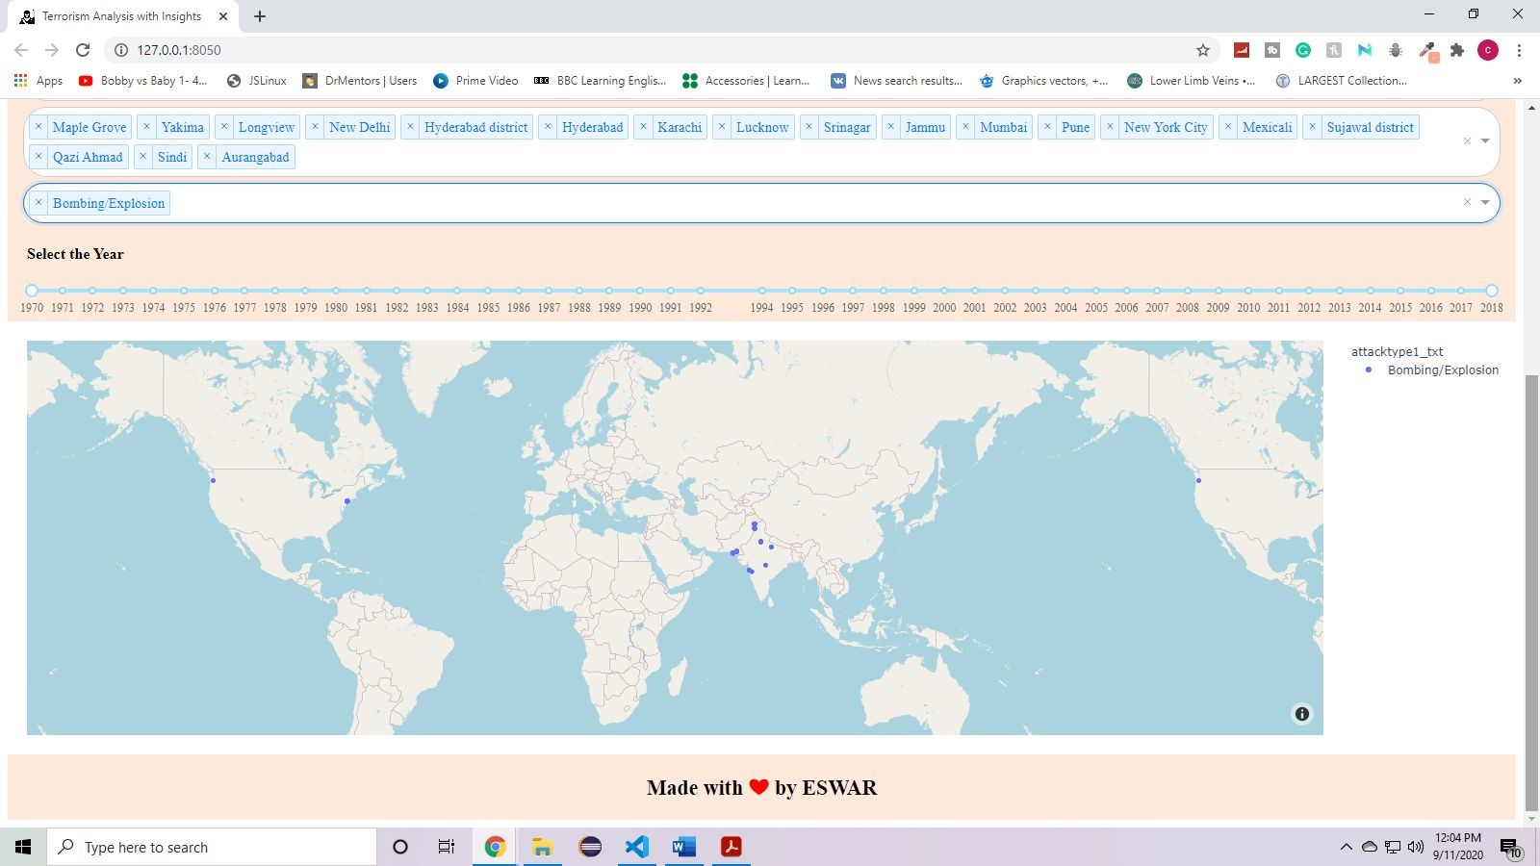

**Fig 3.19 : Global Map Tool - The graph shows filtered data as per selected month, date, region, country, state, city and attack type.**

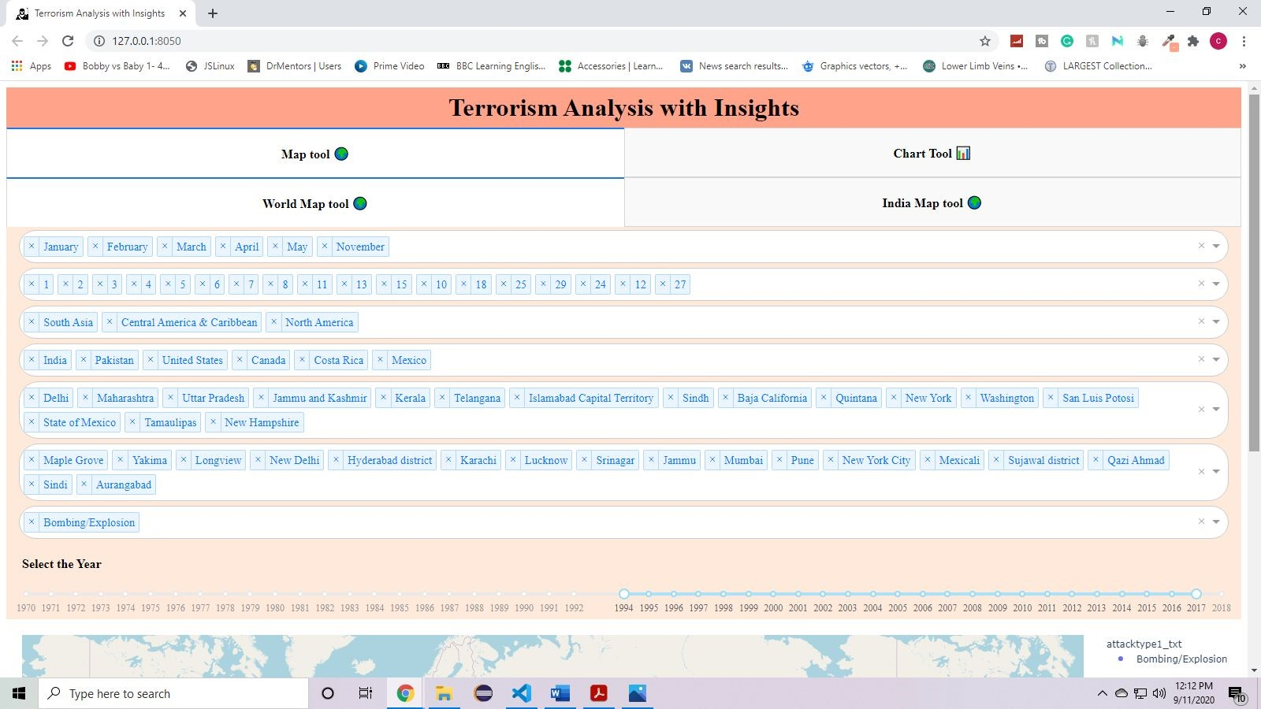

**Fig 3.20 : Global Map Tool - Range of years are selected.**

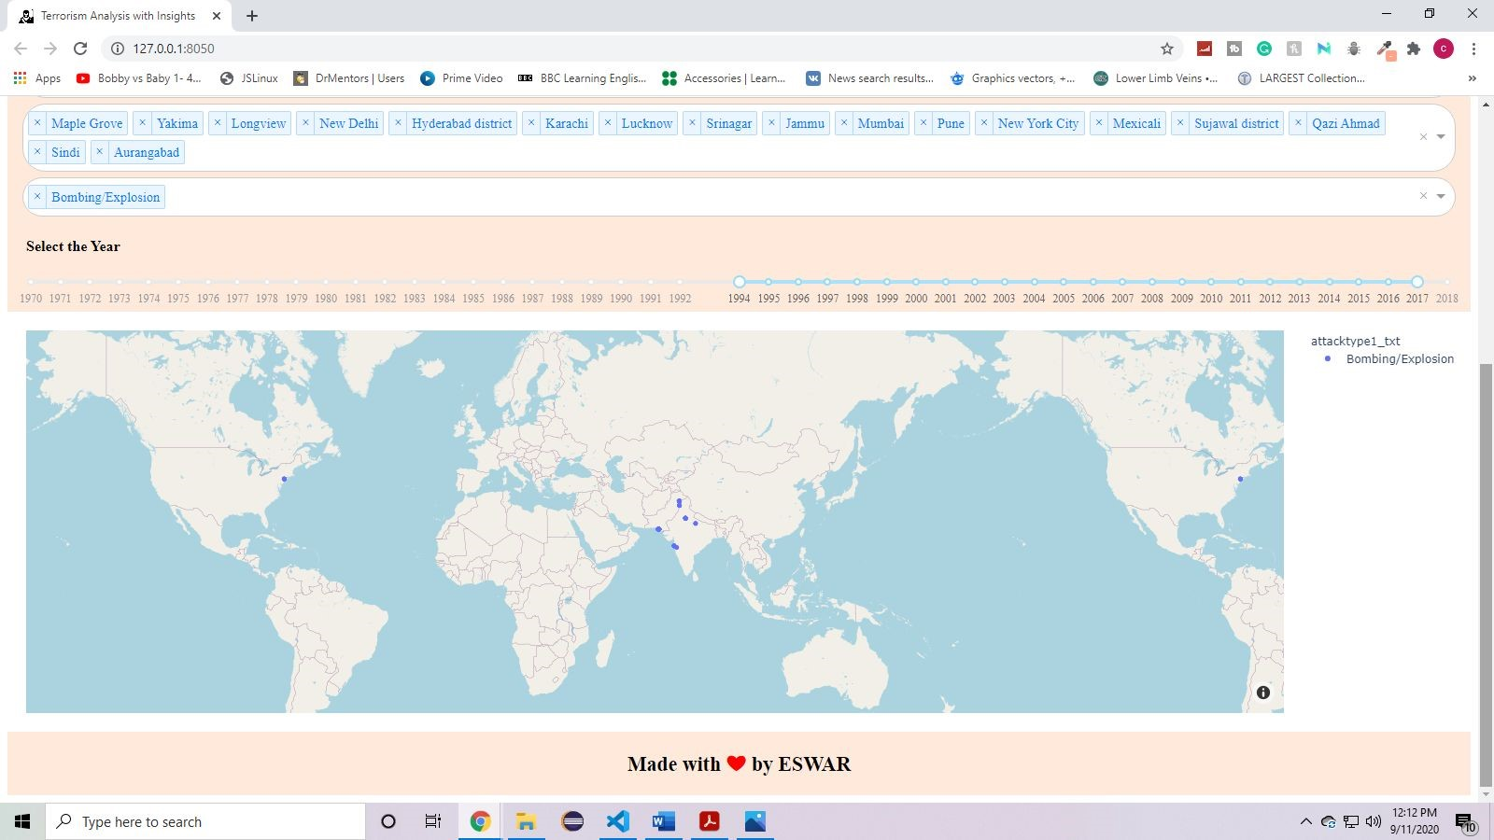

**Fig 3.21 : Global Map Tool - The graph shows filtered data as per selected month, date, region, country, state, city, attack type and years.**

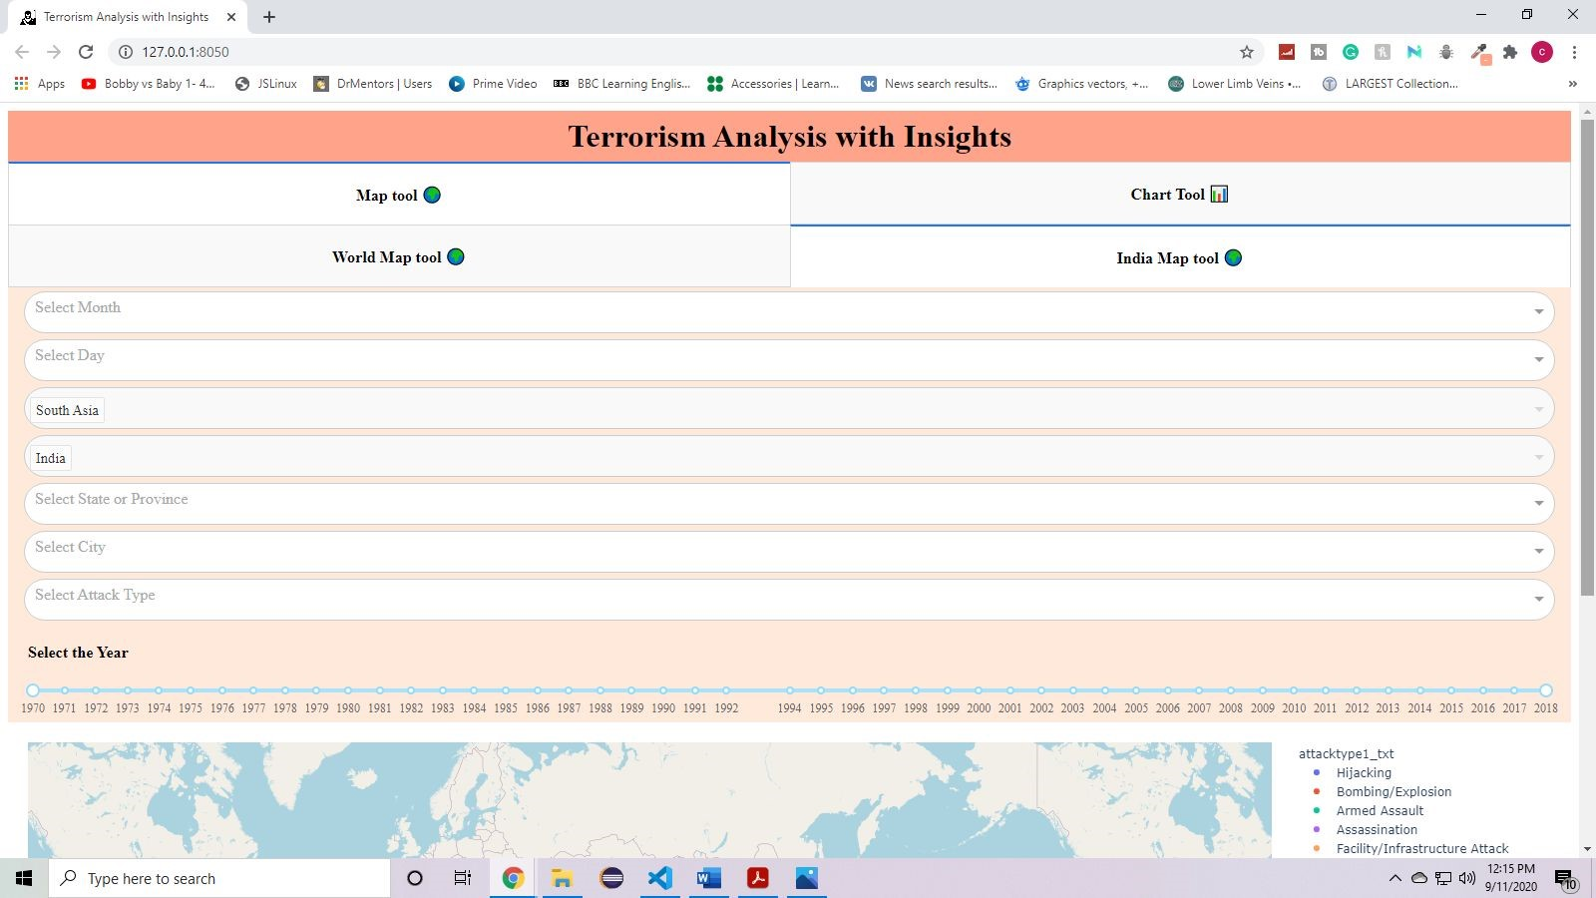

**Fig 3.22 .: India Map Tool - Application depicting without any inputs in dropdown and range slider**

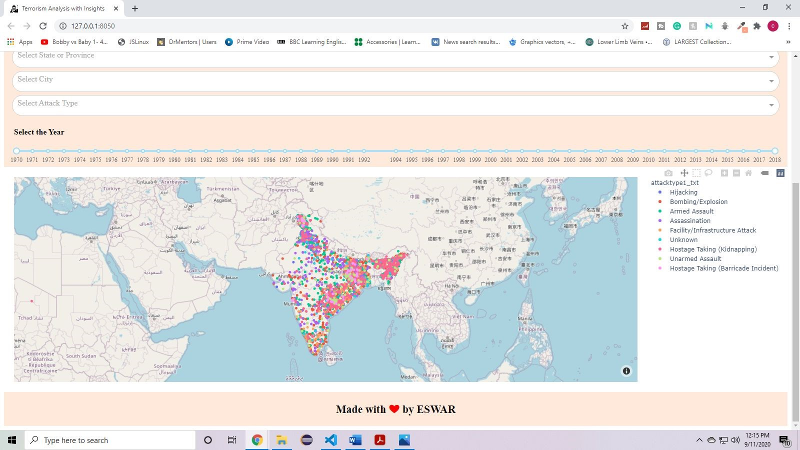

**Fig 3.23 : India Map Tool - The whole data of india is shown without any filters**

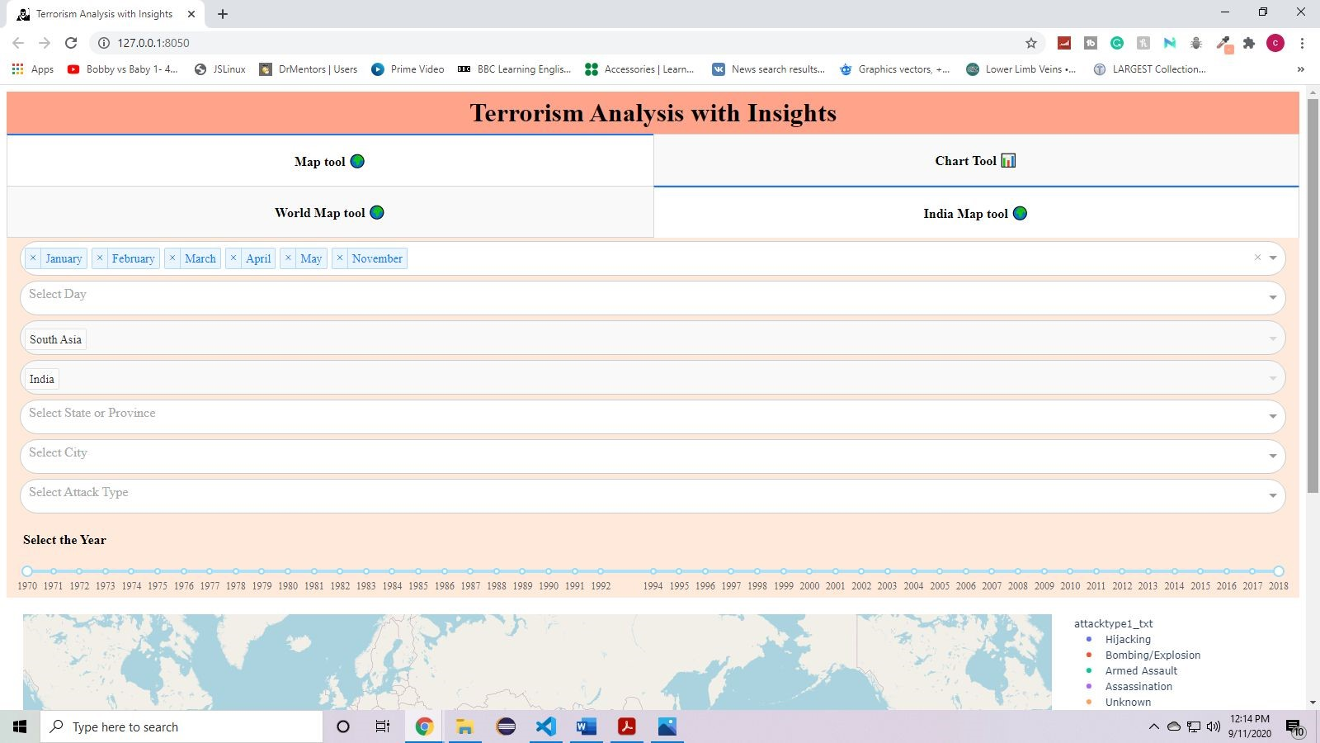

**Fig 3.24 : India Map Tool - Few months are selected as per the user requirements through dropdown**

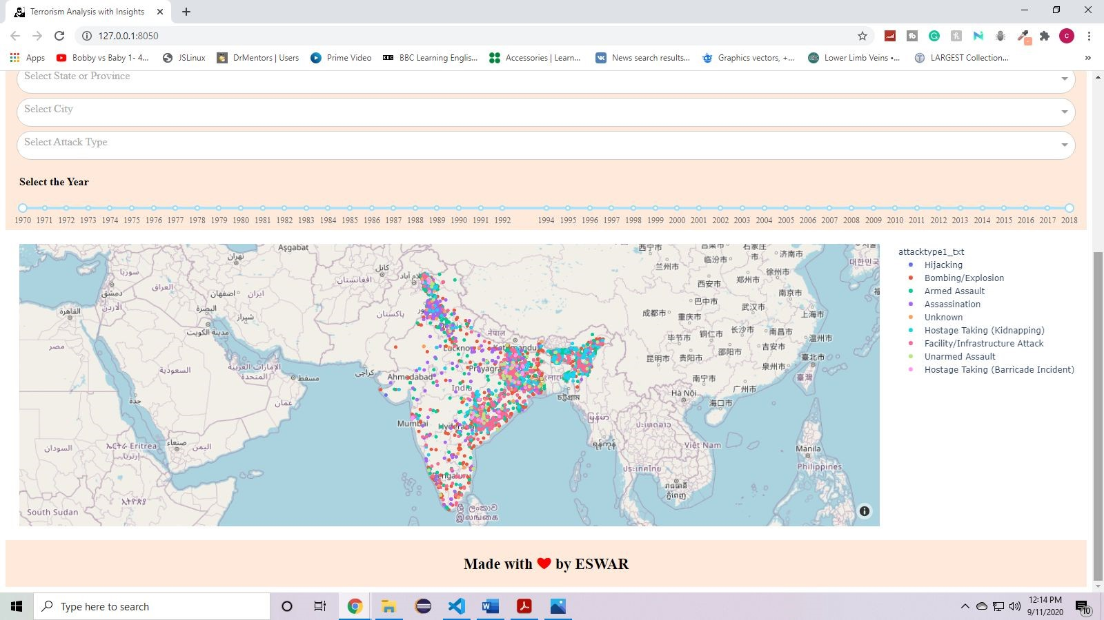

**Fig 3.25 : India Map Tool - The graph shown filtered data as per selected months**

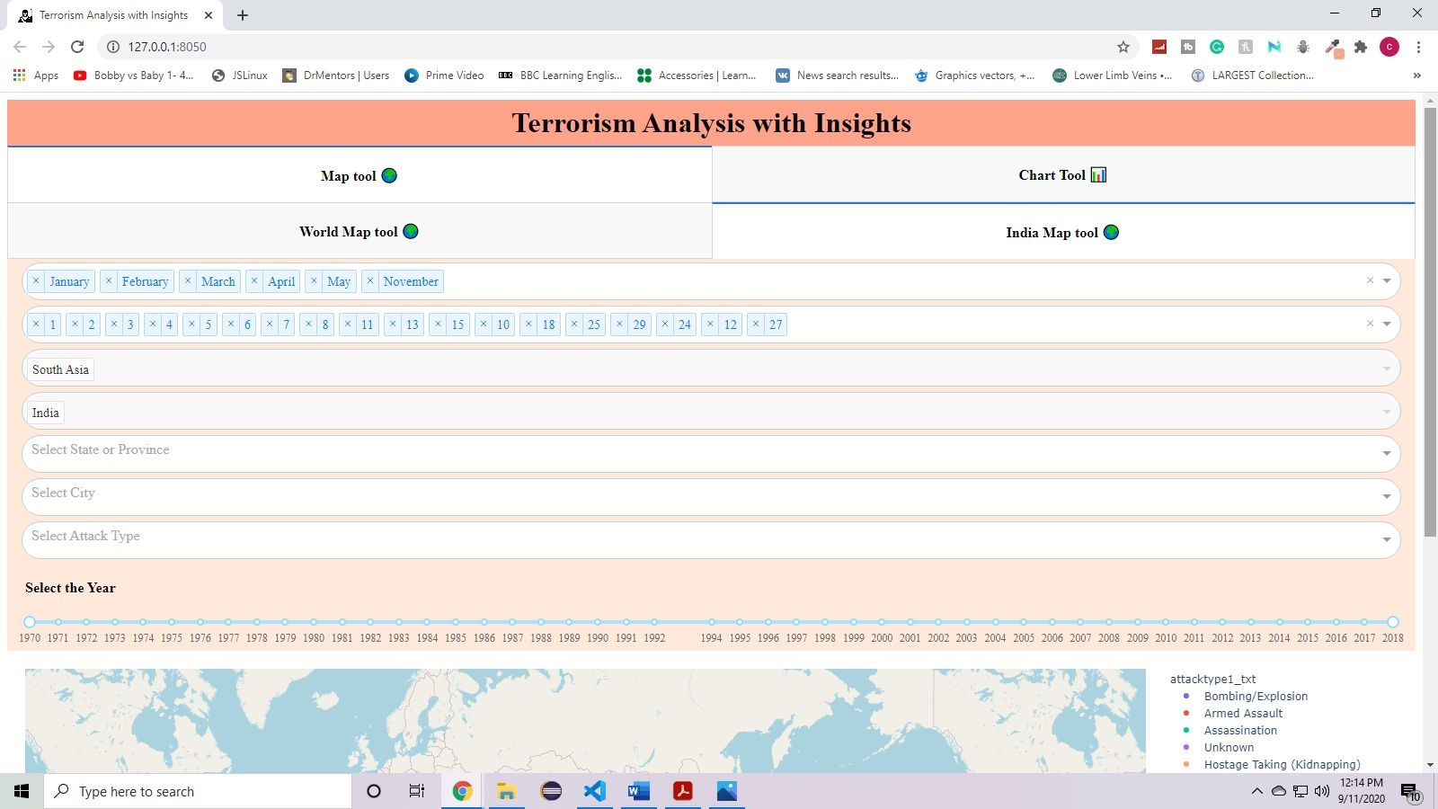

**Fig 3.26 : India Map Tool - Few dates are selected as per selected months**

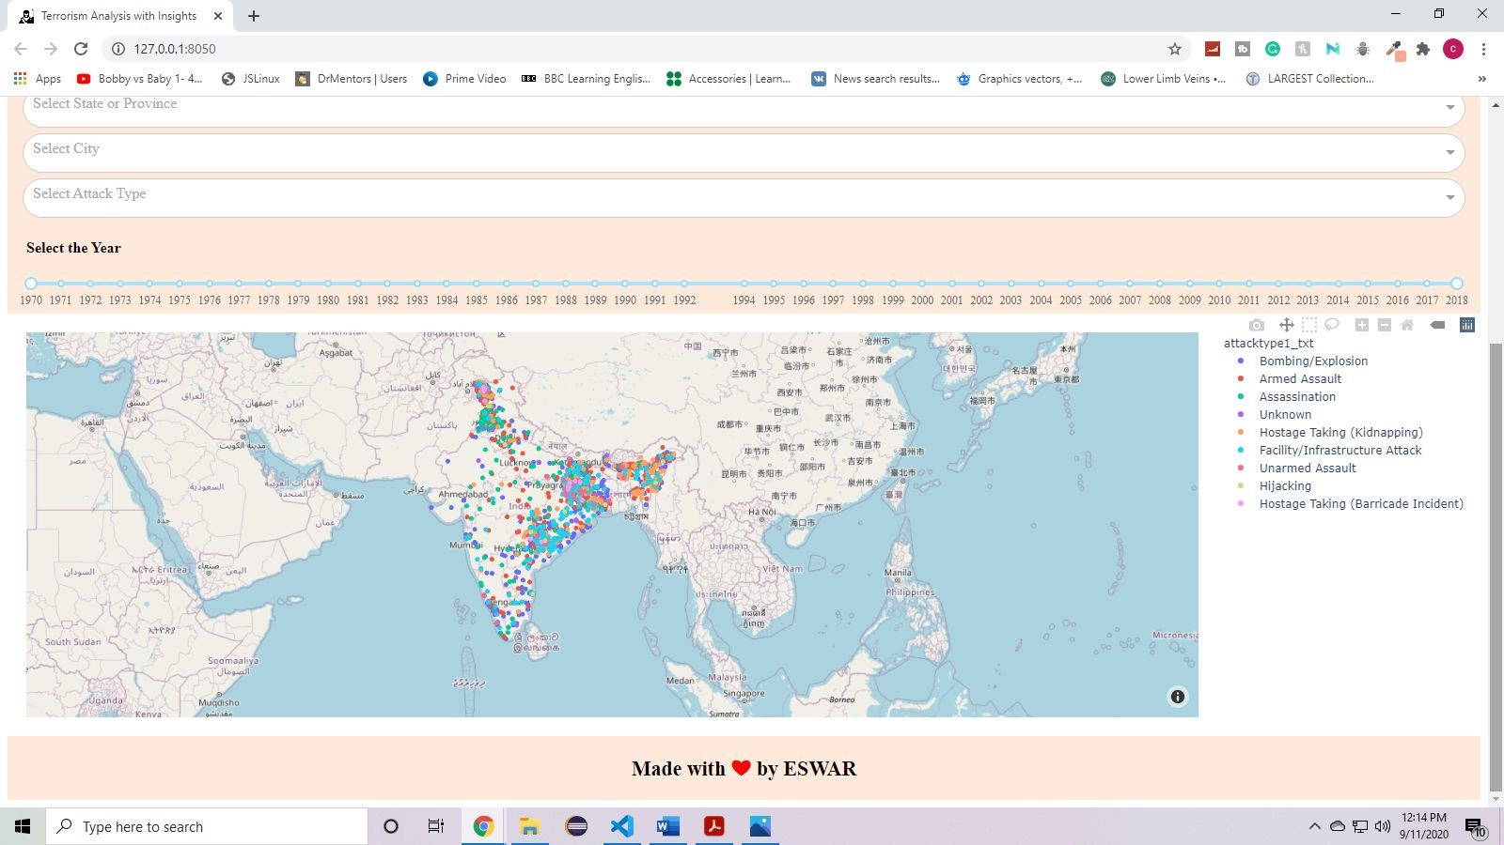

**Fig 3.27 : India Map Tool - The graph shown filtered data as per selected month and date**

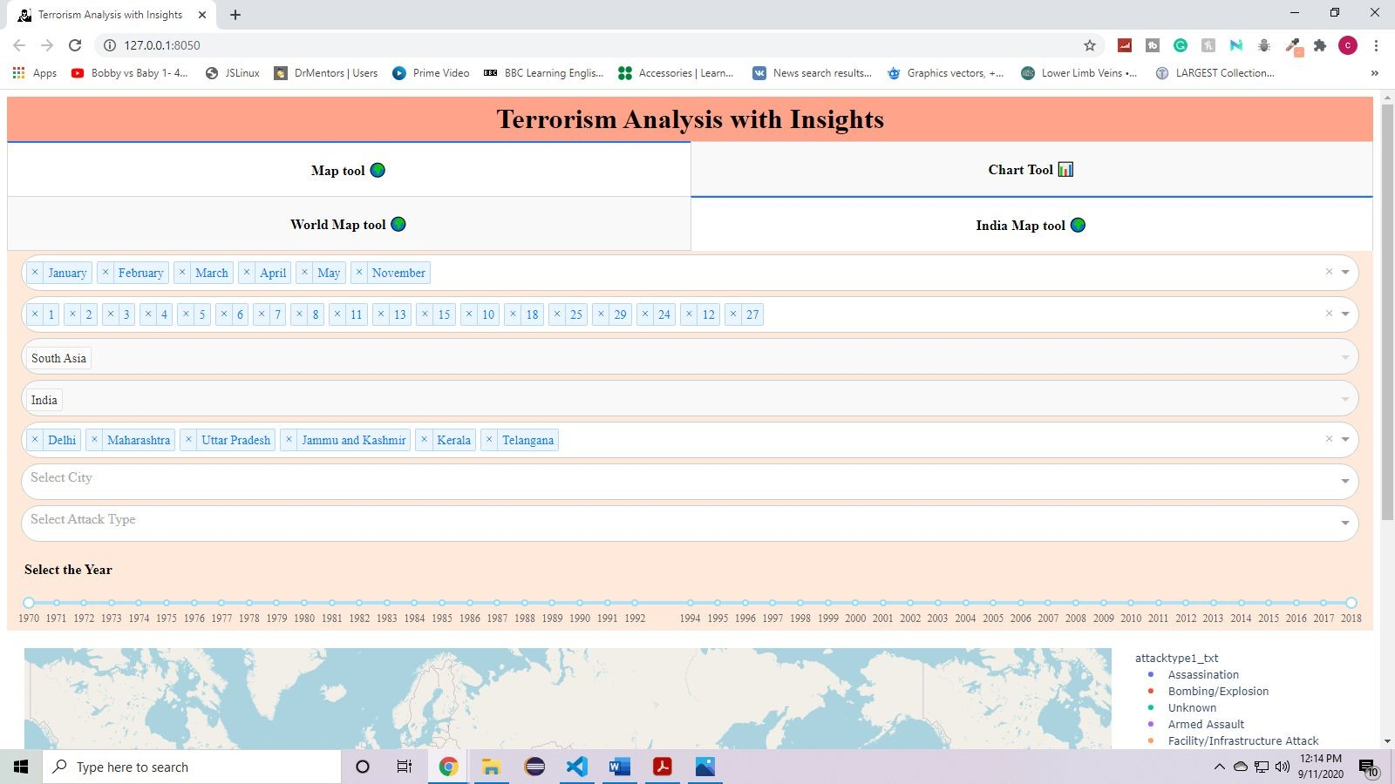

**Fig 3.28 : India Map Tool - Few states from india are selected .**

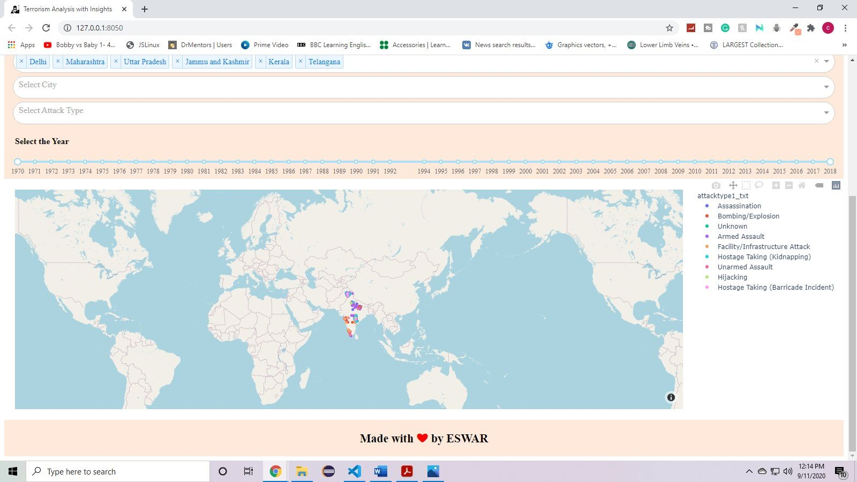

**Fig 3.29: the graph shows filtered data as per selected month, date and state in india**

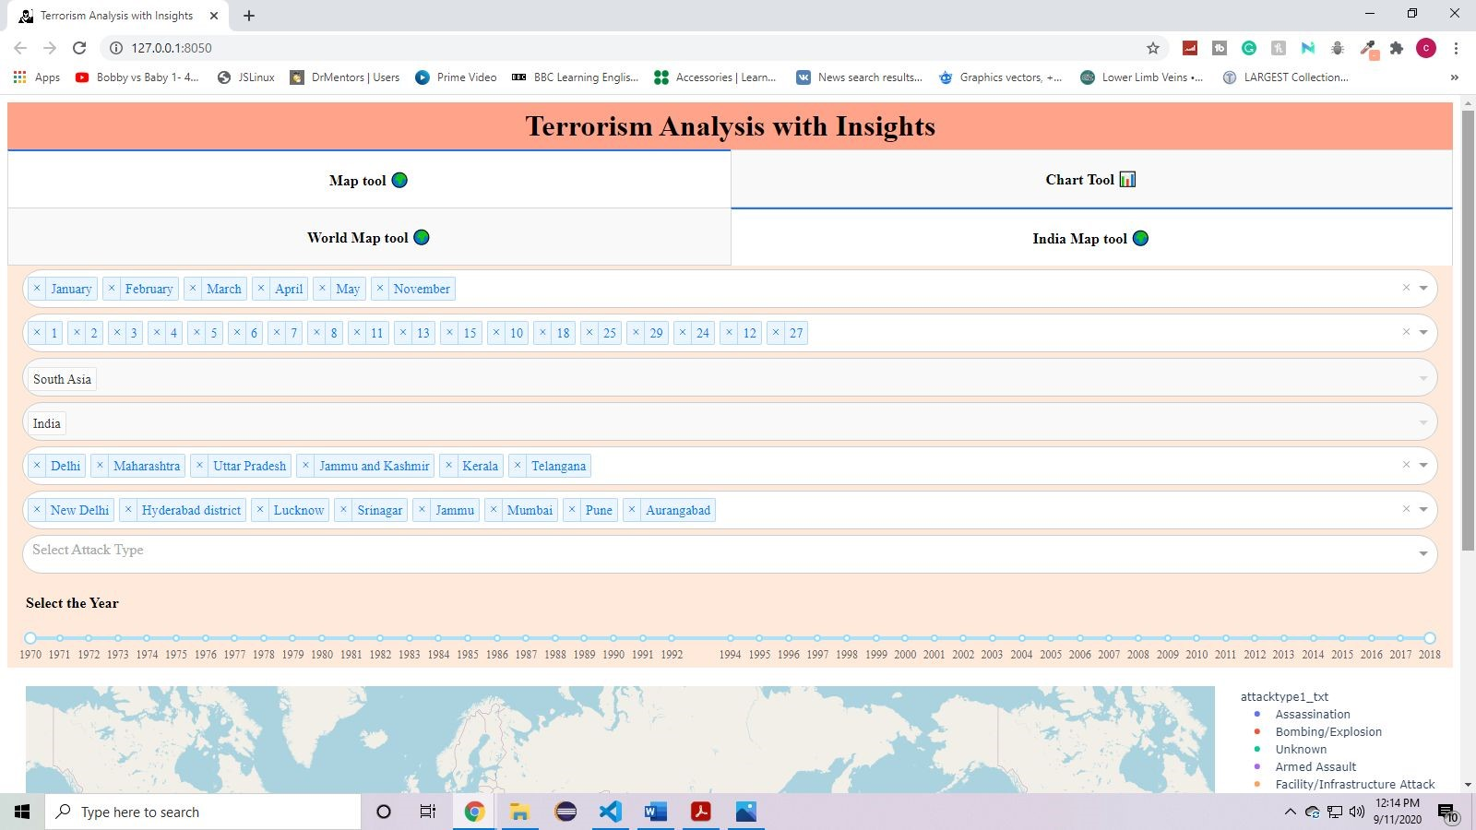

**Fig 3.30: India Map Tool - Few cities are selected based on selected states and in india**

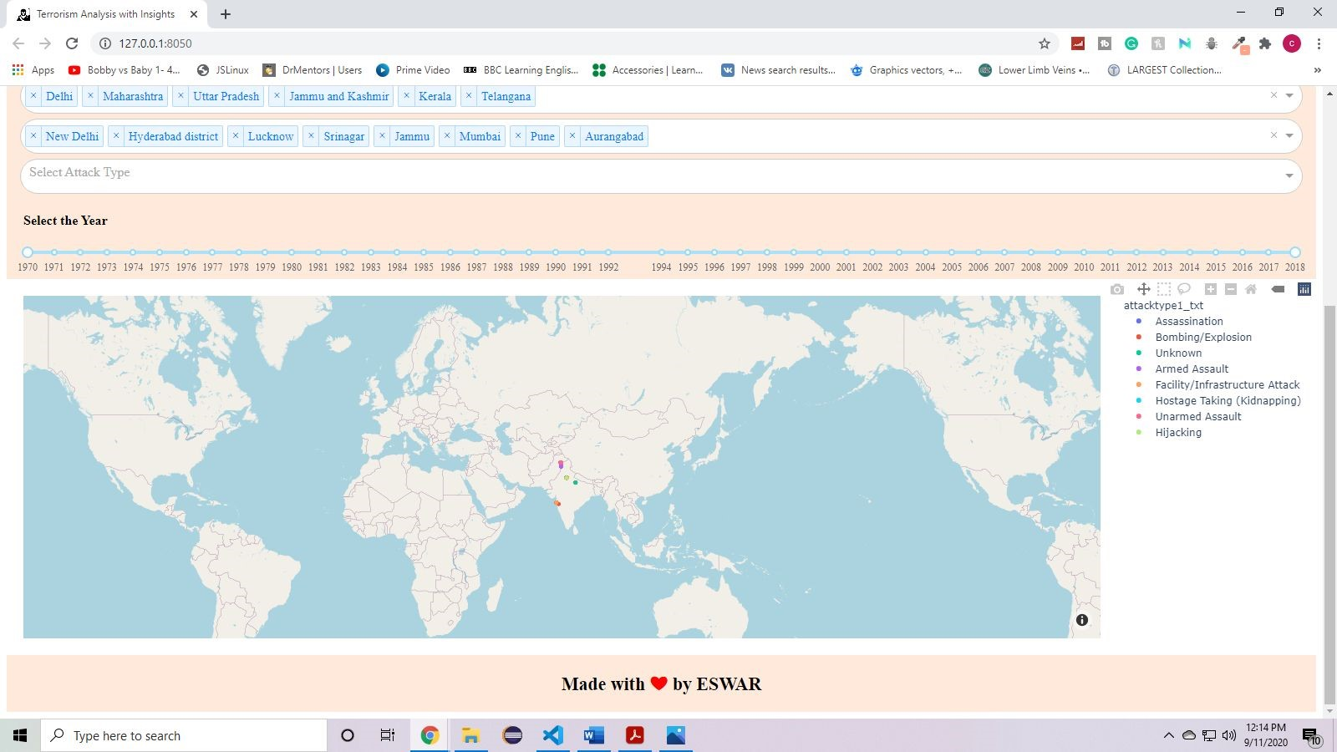

**Fig 3.31 : India Map Tool - The graph shows filtered data as per selected month, date, states and few cities in india**

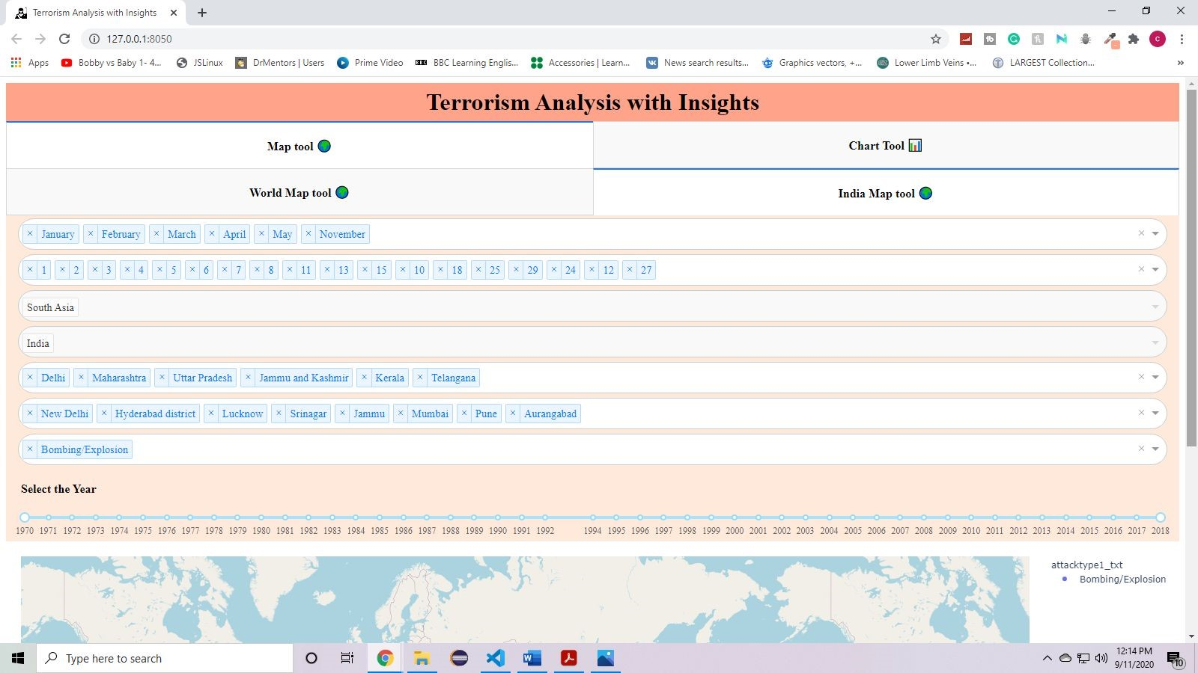

**Fig 3.32 : India Map Tool - An attack type is selected.**

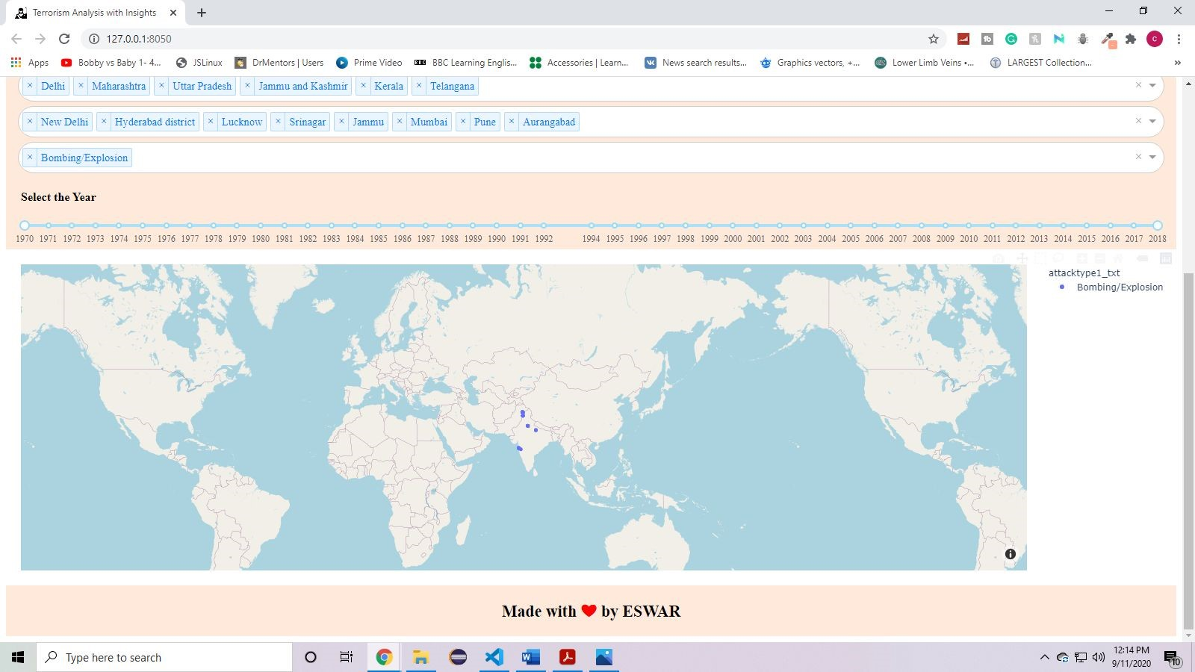

**Fig 3.33: India Map Tool - The graph shows filtered data as per selected month, date, state, city in india and attack type**

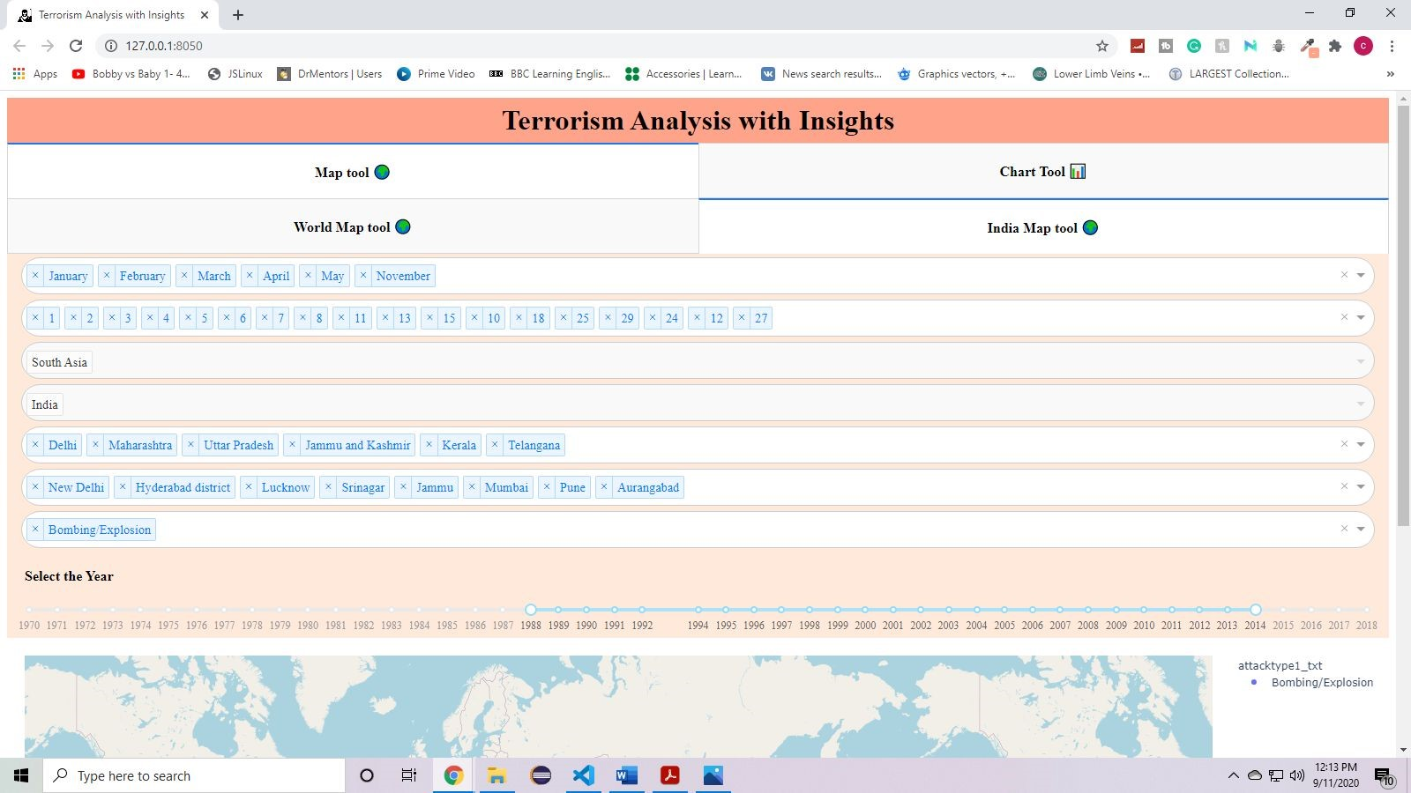

**Fig 3.34 : India Map Tool - A range of year is selected**

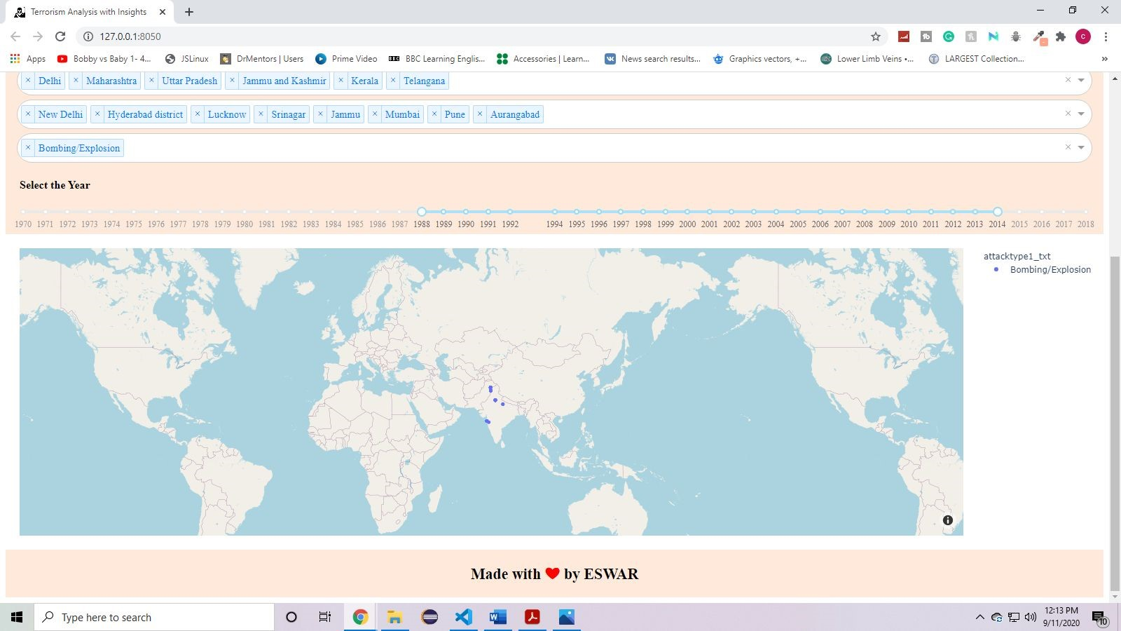

**Fig 3.35 : India Map Tool - The graph shows filtered data as per selected month, date, year, state and city in india and attack type.**

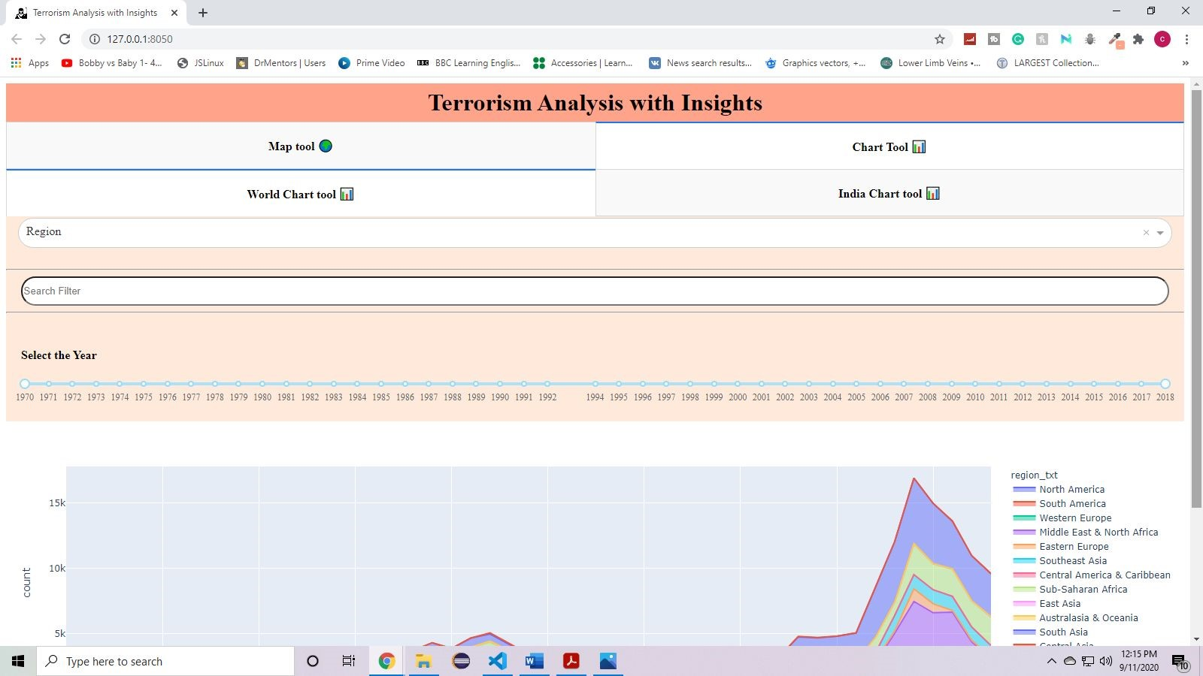

**Fig 3.36 : Global Chart Tool - application - chart tool depicting without any inputs (region selected as default) in dropdown and range slider**

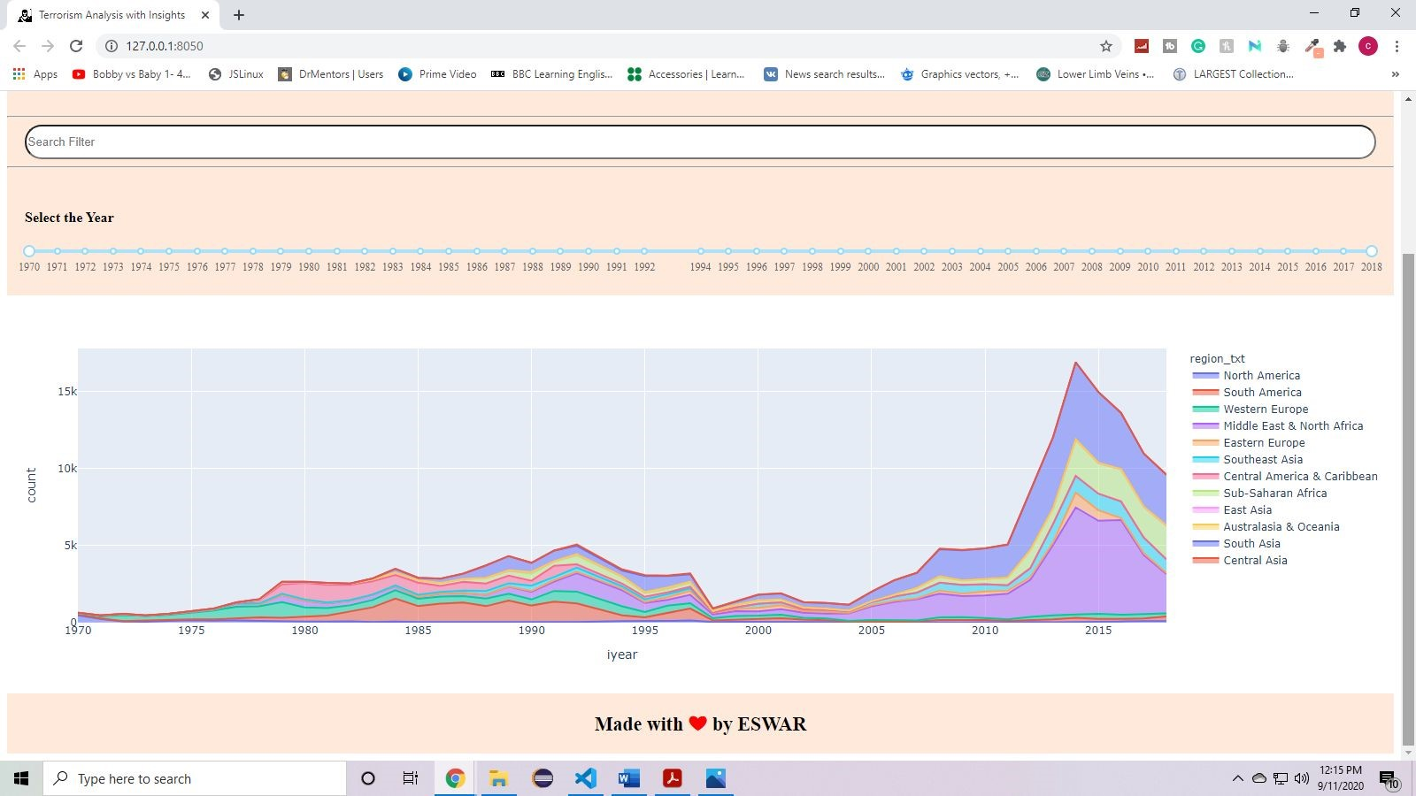

**Fig 3.37 : Global Chart Tool - The whole data shows without any filters**

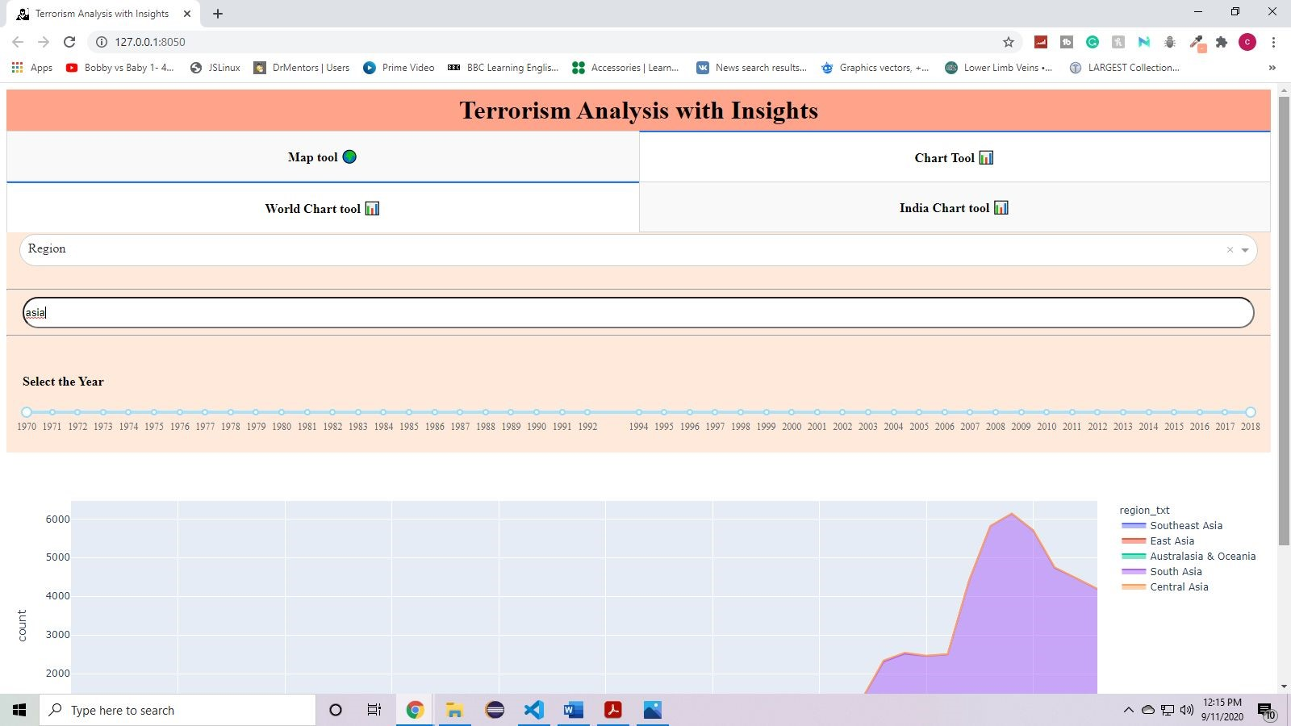

**Fig 3.38 : Global Chart Tool - Search filter is selected as per user requirement**

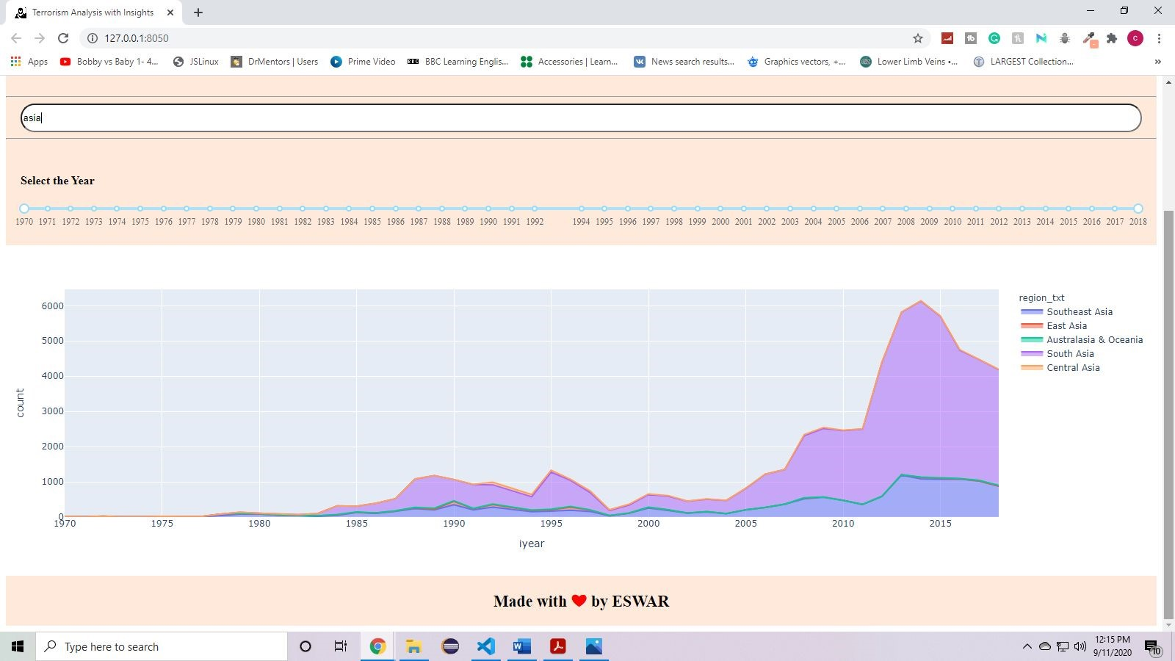

**Fig 3.39 : Global Chart Tool - the chart shows filtered data as per search filter**

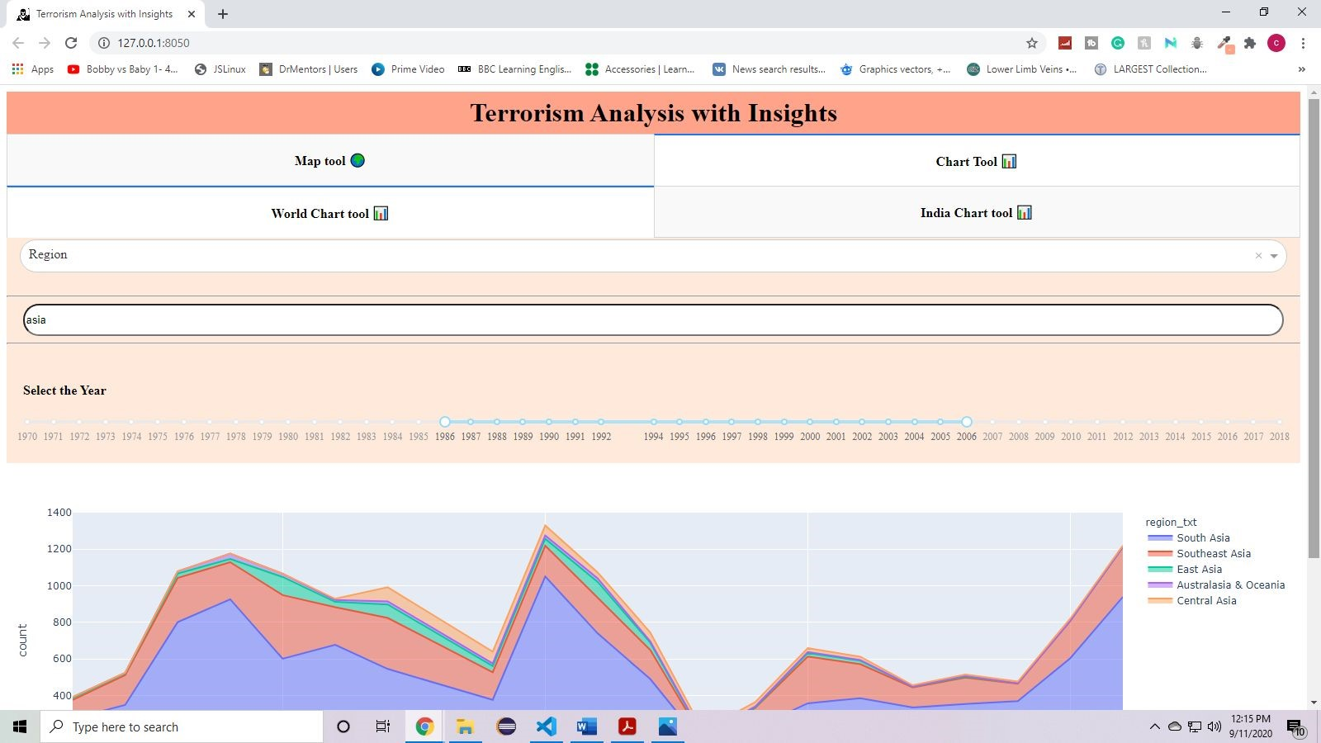

**Fig 3.40: Global Chart Tool - Range of year slider is selected as per the user requirement**

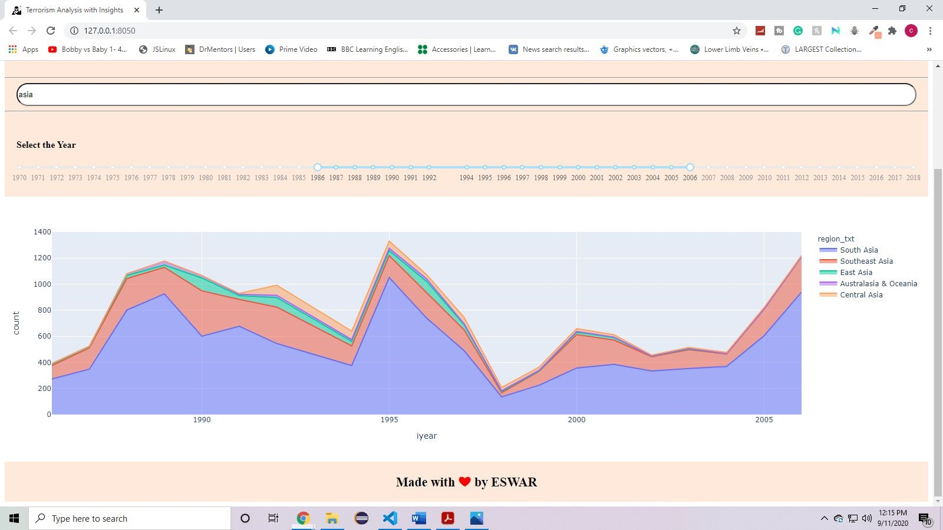

**Fig 3.41: Global Chart Tool - the graph shows filtered data as per search filter and year slider**

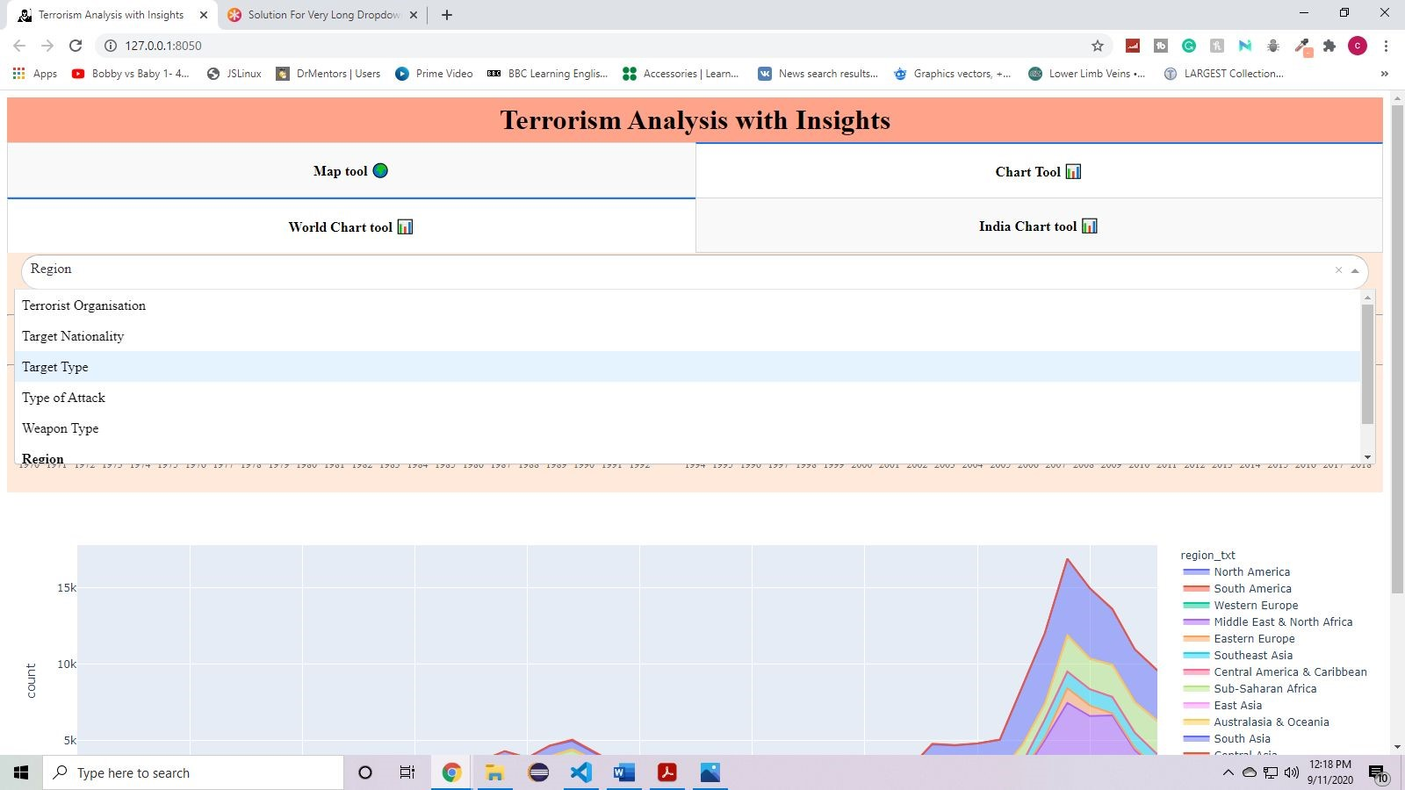

**Fig 3.42 : Global Chart Tool - application depicting dropdown (part 1)**

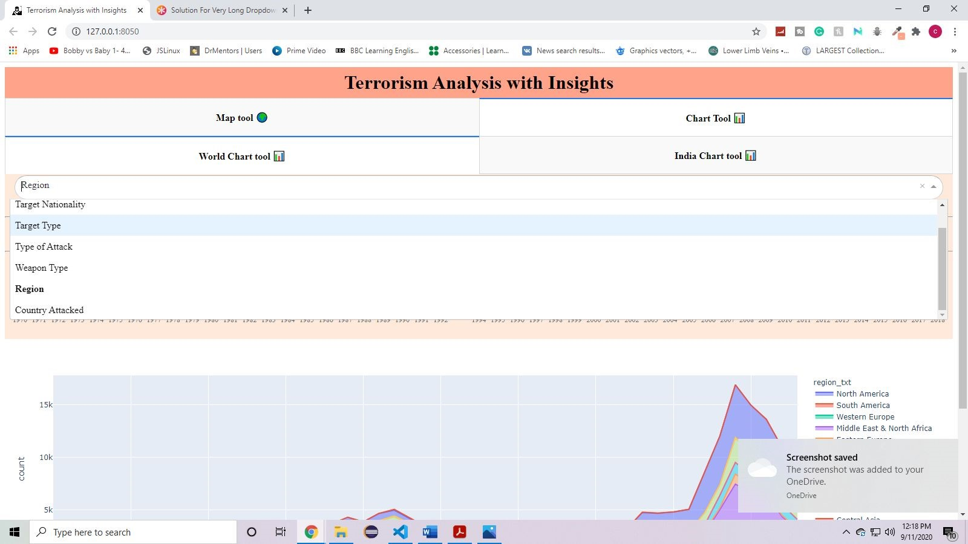

**Fig 3.43 : Global Chart Tool - Application depicting dropdown (part 2)**

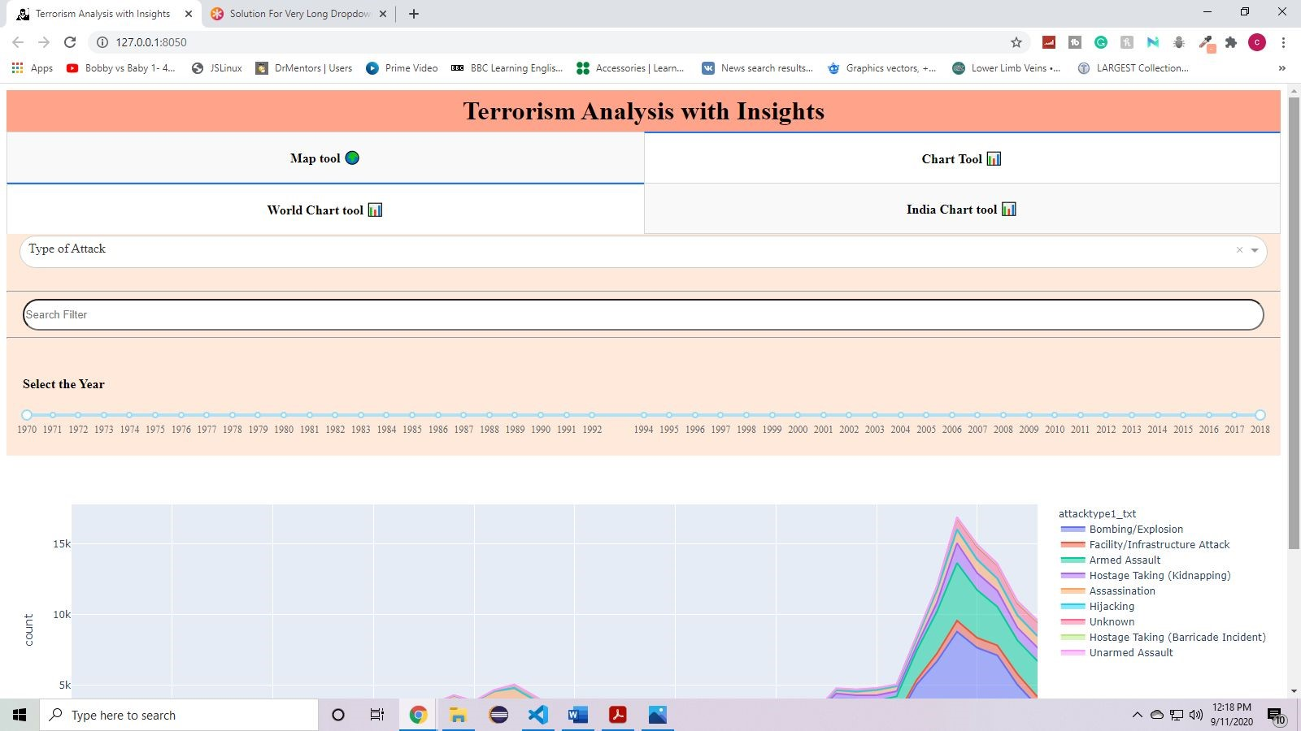

**Fig 3.44 : Global Chart Tool - Type of attack is selected as per user requirements**

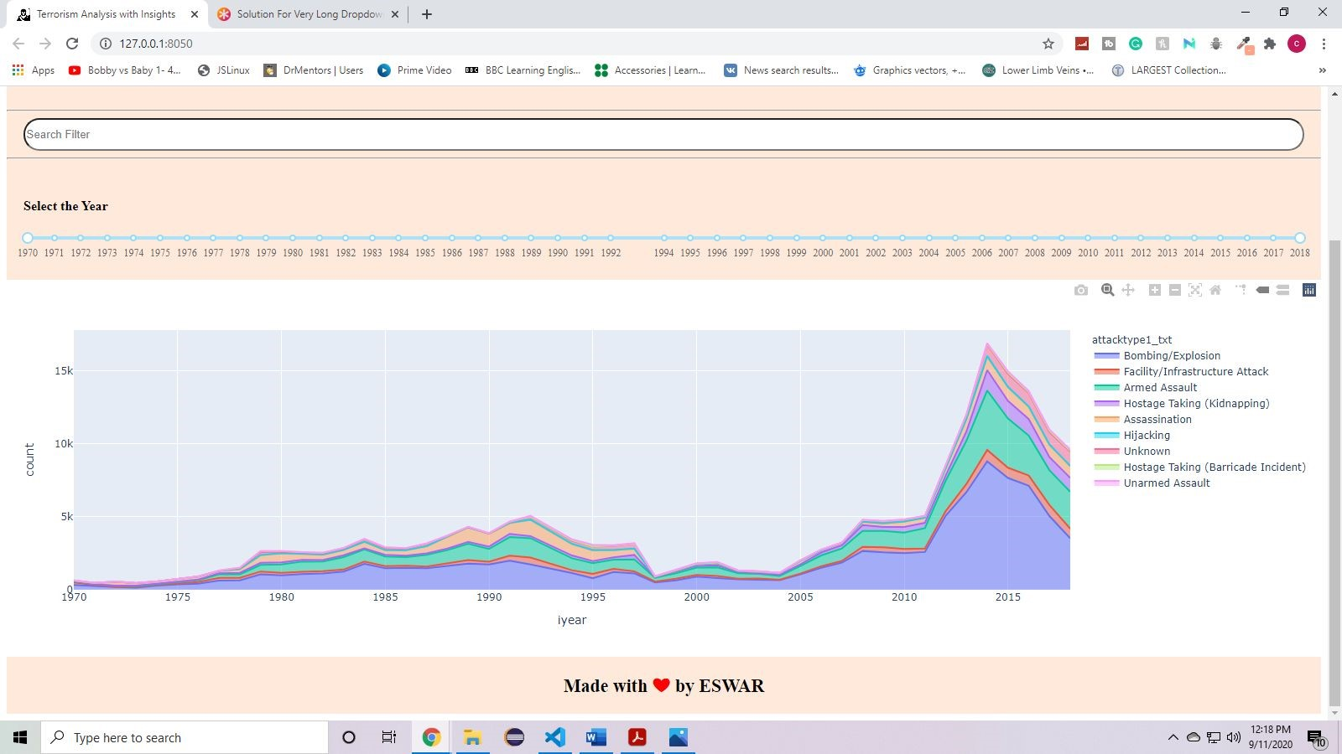

**Fig 3.45: Global Chart Tool - The graph shows filtered data as per type of attack**

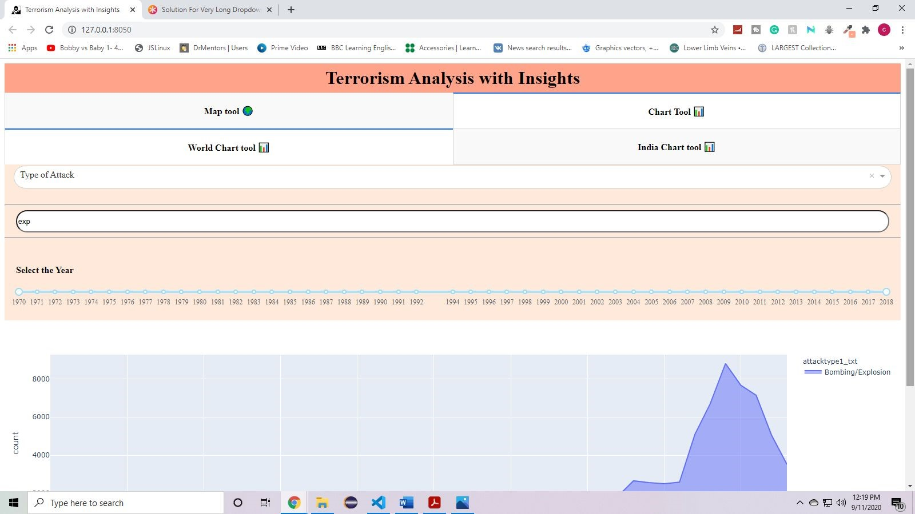

**Fig 3.46 : Global Chart Tool -Search filter is selected as per user requirement (exp)**

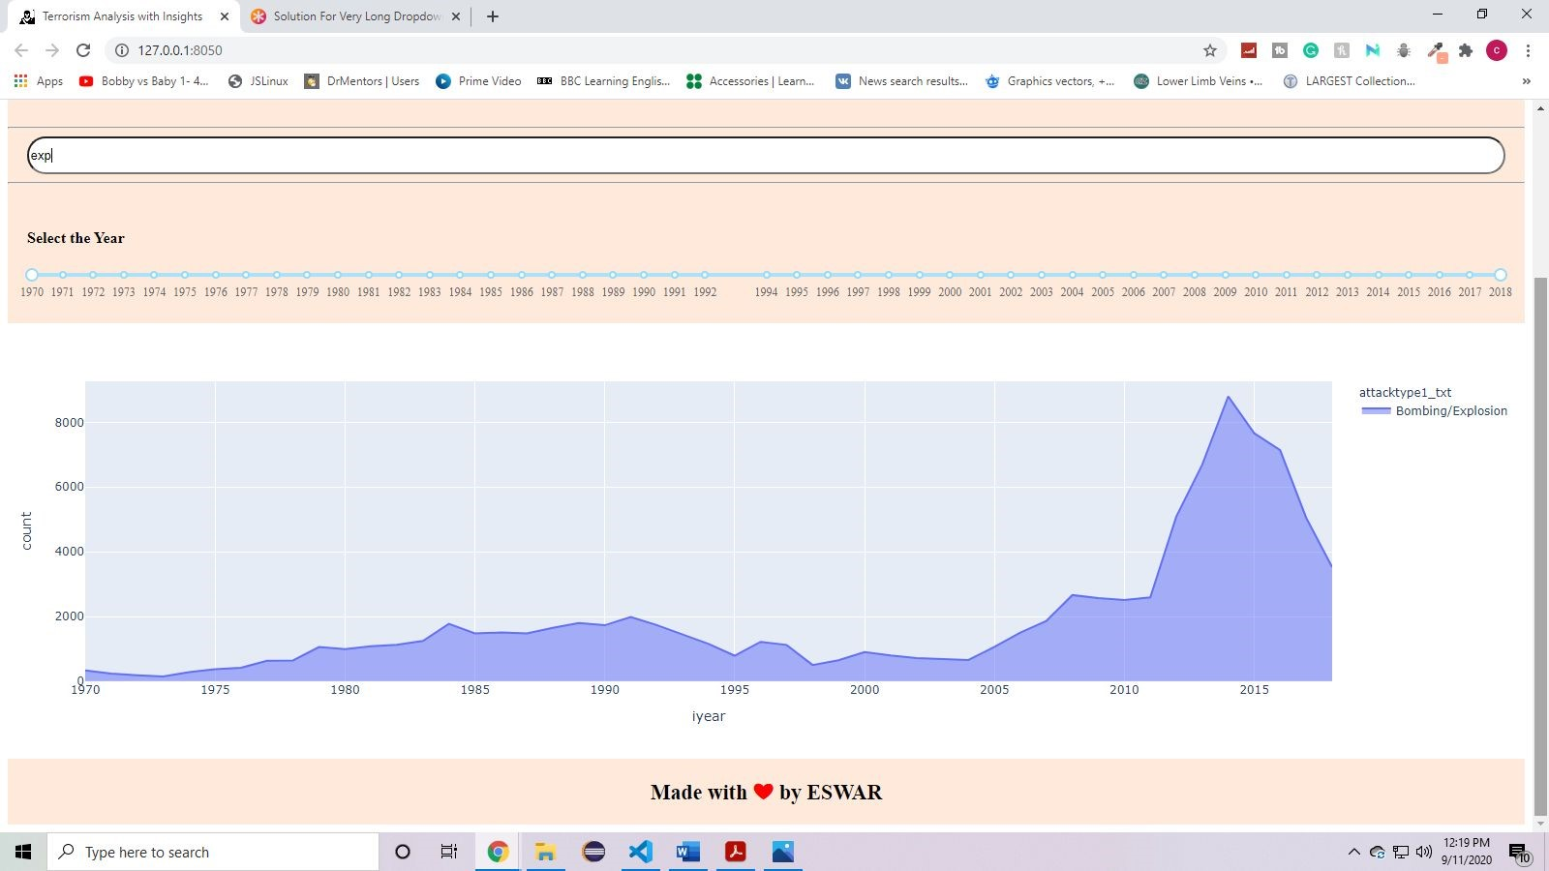

**Fig 3.47 : Global Chart Tool - The graph shows filtered data as per search filter and type of attack**

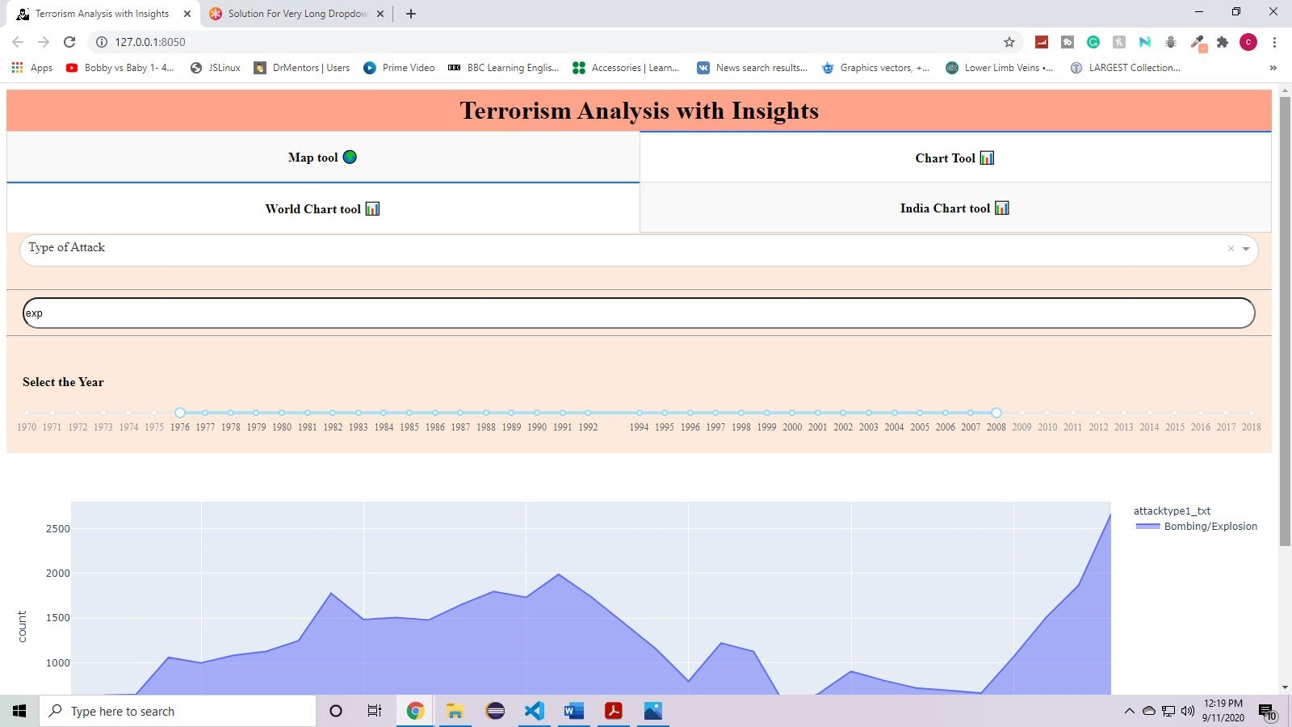

**Fig 3.48: Global Chart Tool - A range of year is selected using range slider**

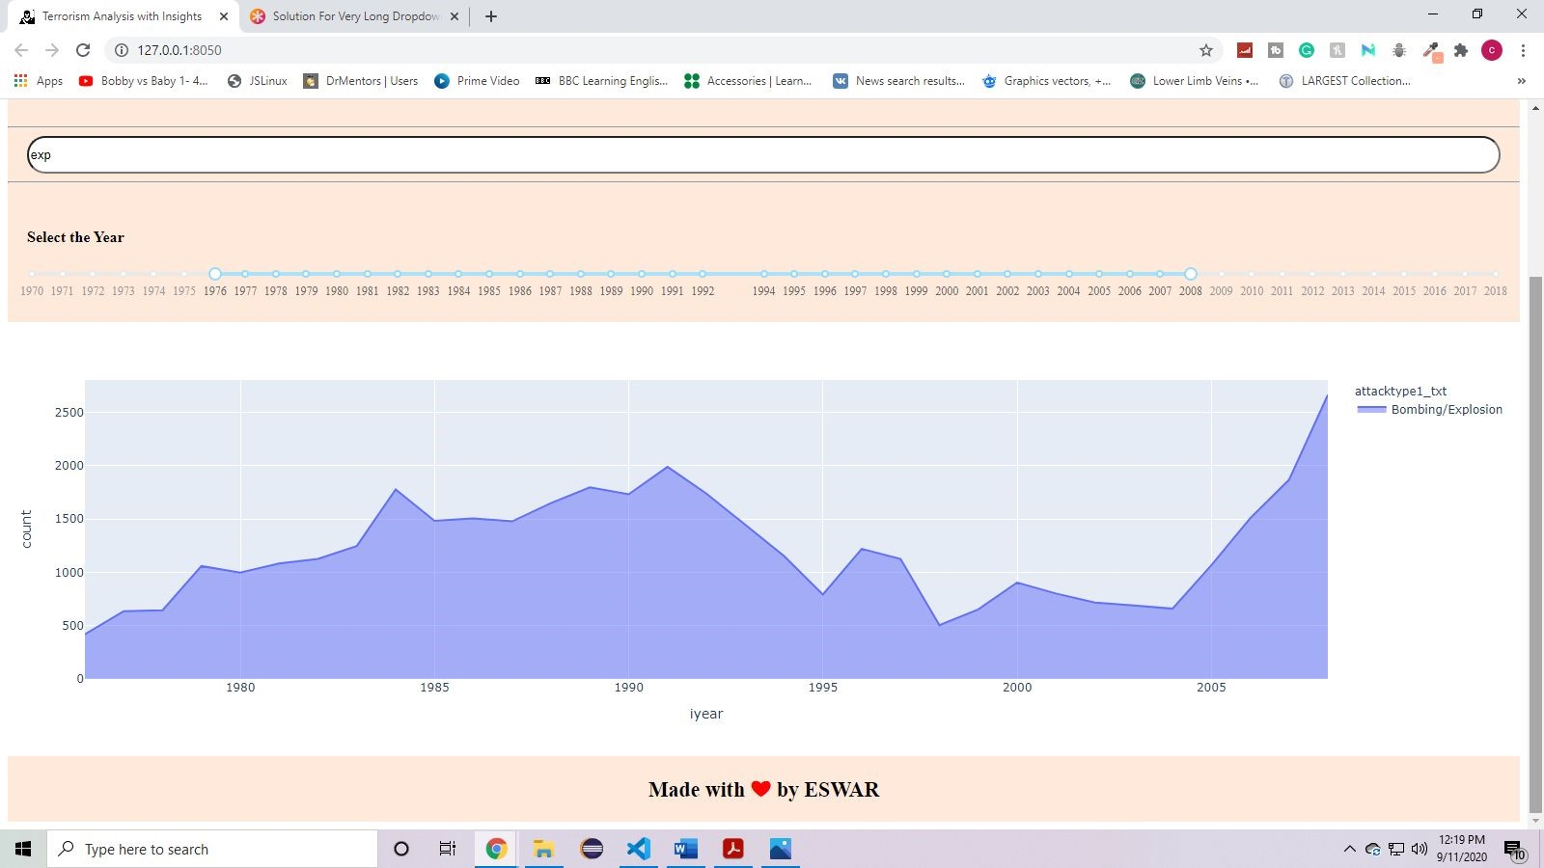

**Fig 3.49 : Global Chart Tool - The graph shows filtered data as per attack type, search filter and year slider**

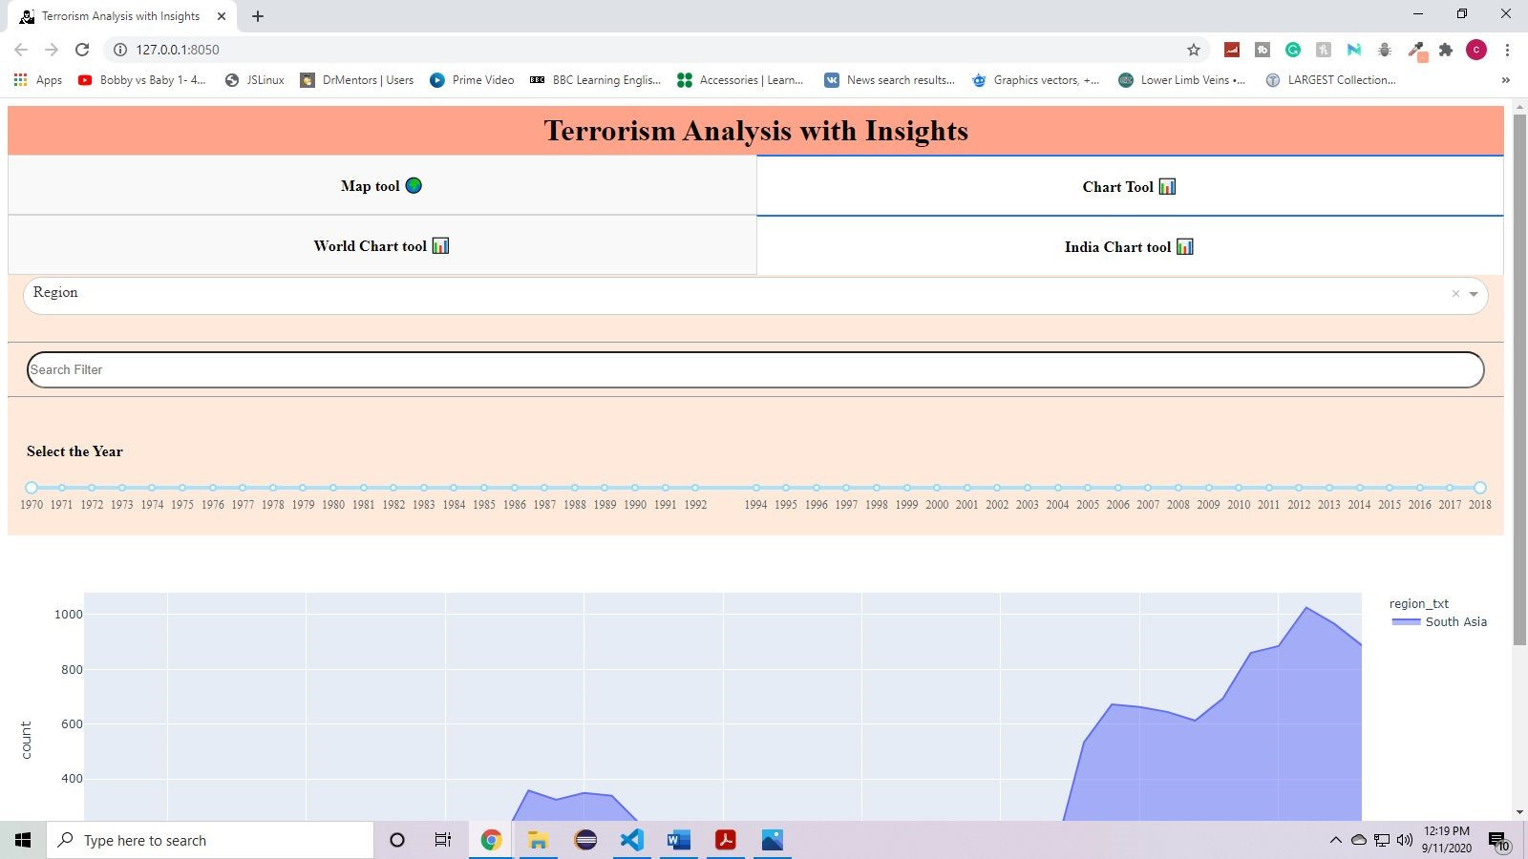

**FIg 3.50 : India Chart Tool - The whole data of terrorism in india is shown without any filters (region is selected as default )**

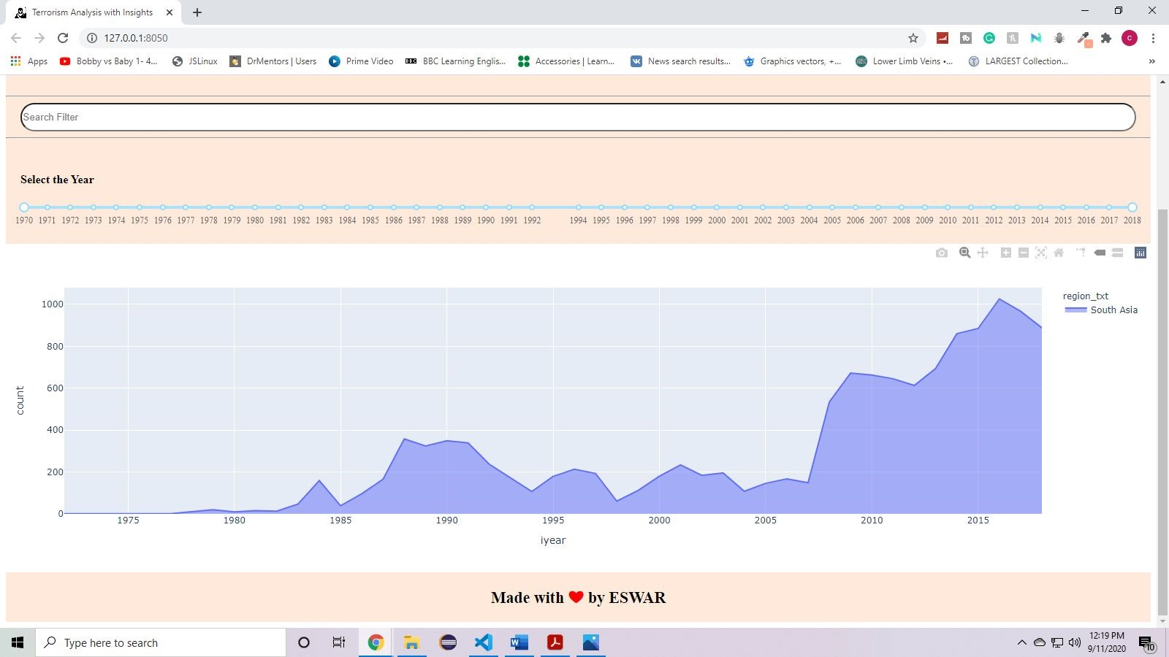

**Fig 3.51 : India Chart Tool - The graph shows filtered data as per region in india**

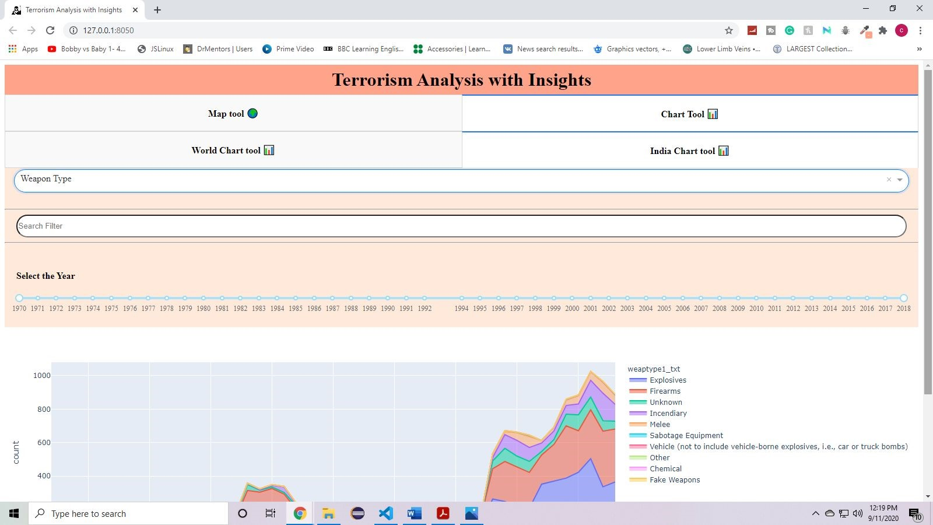

**Fig 3.52 : India Chart Tool - Type of weapon is selected as per user requirements through dropdown**

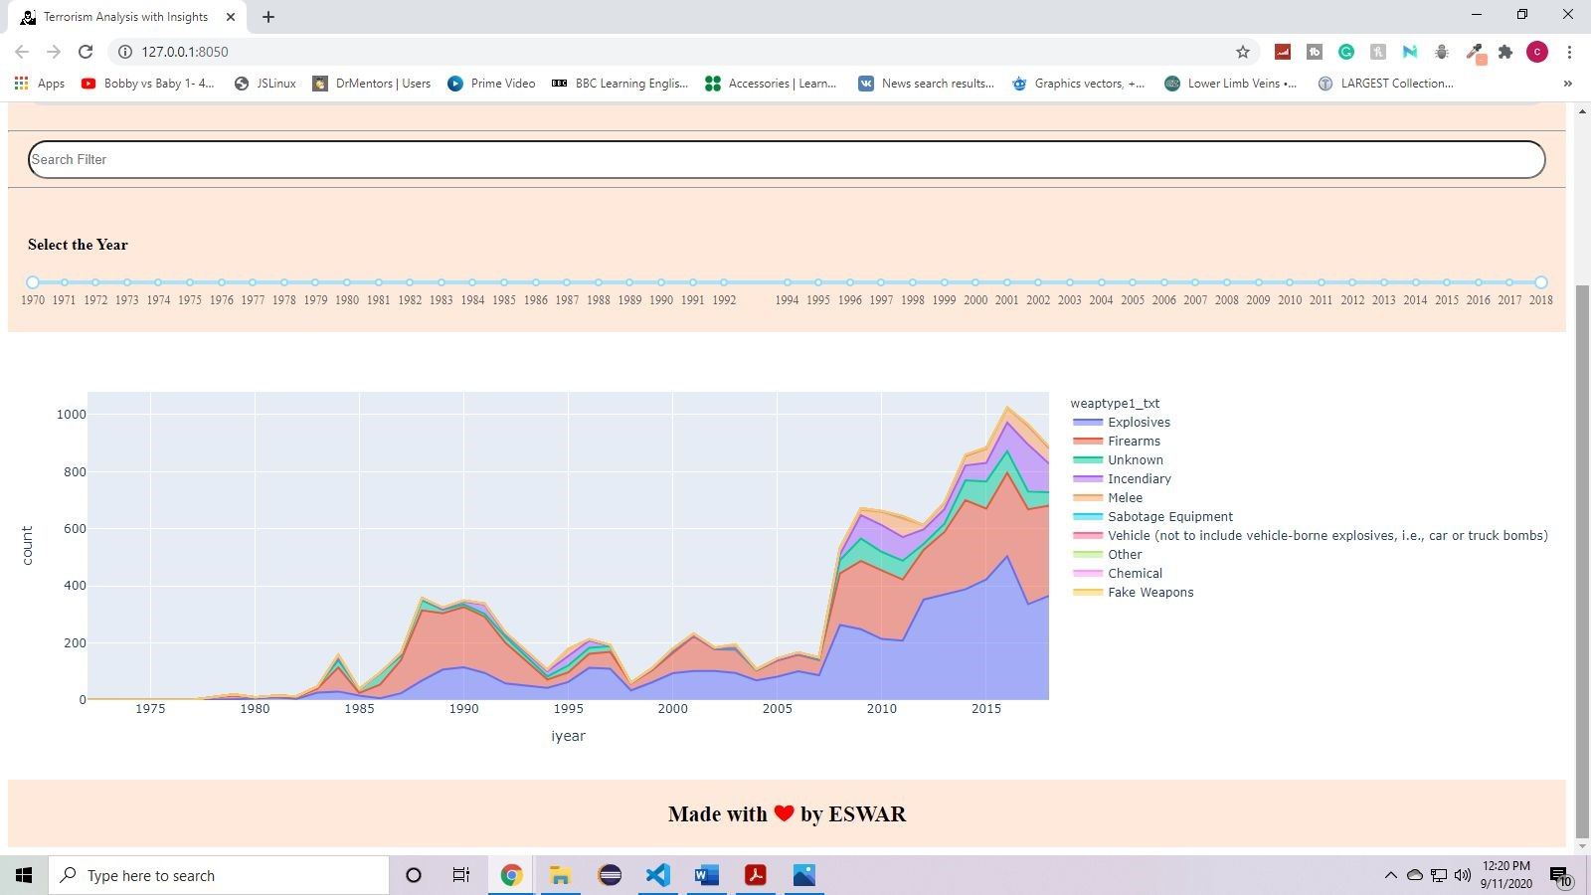

**Fig 3.53 : India Chart Tool The graph shows filtered data as per type of weapon**

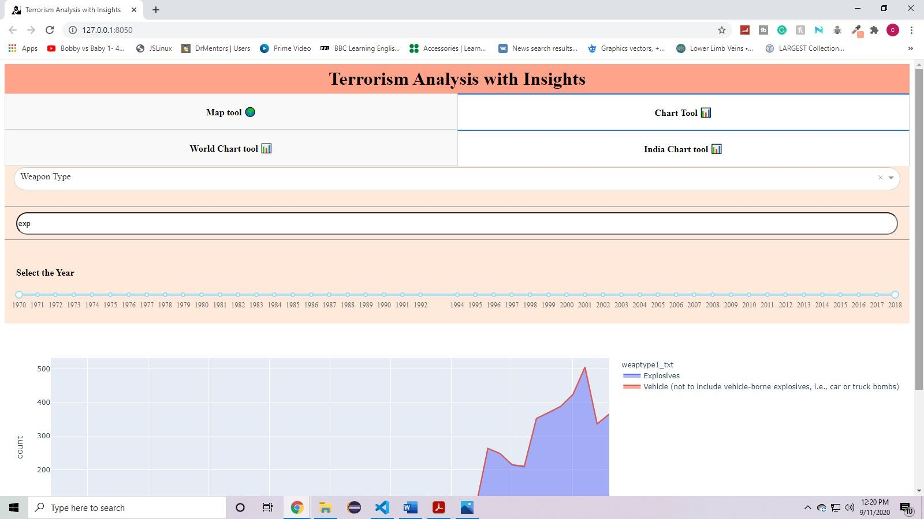

**Fig 3.54 : India Chart Tool - The search filter is selected as per user requirement (exp)**

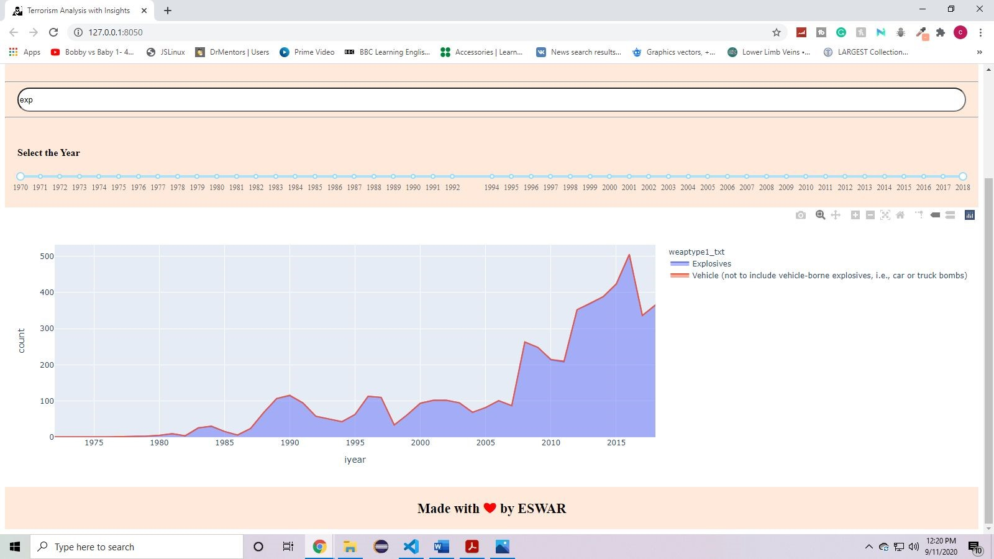

**Fig 3.55 : India Chart Tool - The graph shows filtered data as per search filter and type of weapon.**

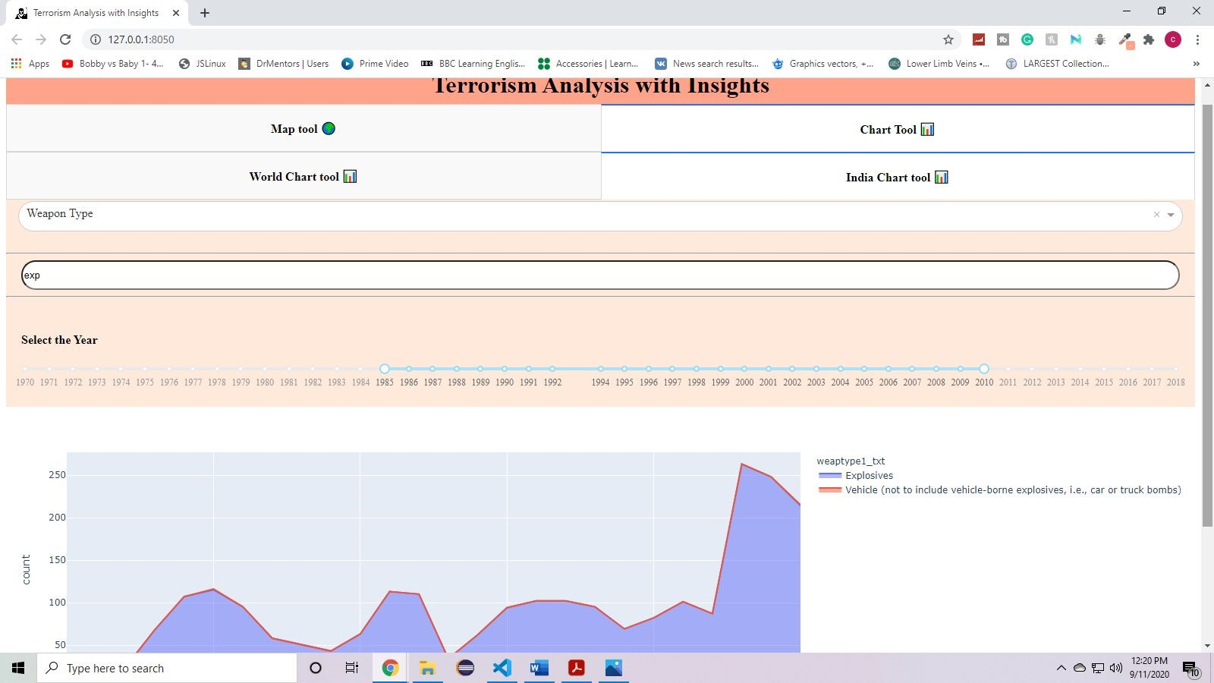

**Fig 3.56 : India Chart Tool - Range of years is selected using range slider**

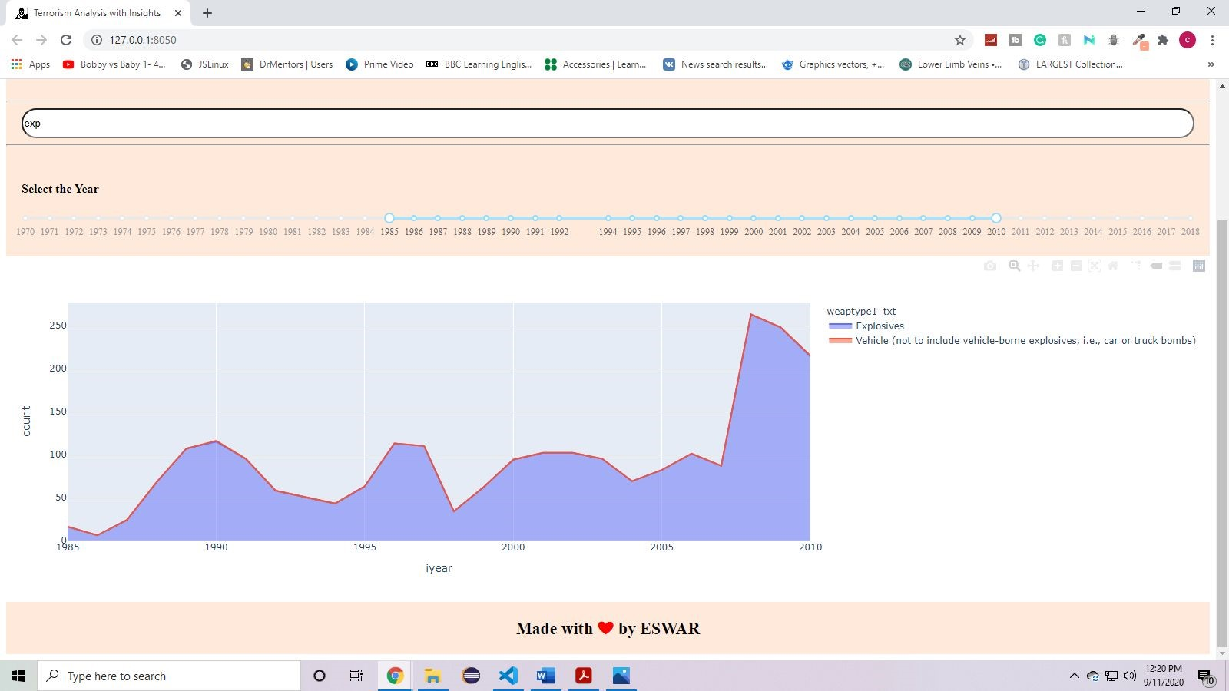

**Fig 3.57 : India Chart Tool - The graph shows filtered data as per type of weapon, search filter and year slider**

# 4. Conclusion and future work

The application helps the user to collect insights of the data.

Using multiple filters and dropdowns, the data is filtered as per user requirements and the data is shown in terms of maps and charts colorfully.

It helps in identifying different types of attacks in map tool and progression of attacks in chart tools with respect to year.

Each event data is shown on the mouse hover on a particular event

**Future Work:**

The project can be further improved by adding future predictions.

**5. Acknowledgements:**

My acknowledgements to Dr. Sylvester Fernandes, Forsk Coding School and Yogendra Singh for guiding me in completion of the project “terrorism analysis with insights using Python”.

# 6. References:

1. [https://towardsdatascience.com/how-to-build-a-complex-reporting-dashboard-using-d ash-and-plotl-4f4257c18a7f](https://towardsdatascience.com/how-to-build-a-complex-reporting-dashboard-using-dash-and-plotl-4f4257c18a7f)
2. <https://www.dash.org/>
3. <https://plotly.com/>
4. [https://www.youtube.com/watch?v=Ma8tS4p27JI&list=PLH6mU1kedUy8fCzkTTJl wsf2EnV_UvOV-&index=1](https://www.youtube.com/watch?v=Ma8tS4p27JI&list=PLH6mU1kedUy8fCzkTTJlwsf2EnV_UvOV-&index=1)
5. <https://stackoverflow.com/>

# 7. Biography:

I am Ayushi Singhal, pursuing my 3rd year of Bachelor of computer application from institute of applied medicine and research Ghaziabad , Uttar Pradesh